**Basic Terminologies of Billing and EDI**

**HIPPA**

The Health Insurance Portability and Accountability Act of 1996 (HIPAA) is a federal law that required the creation of national standards to protect sensitive patient health information from being disclosed without the patient’s consent or knowledge. The US Department of Health and Human Services (HHS) issued the HIPAA Privacy Rule to implement the requirements of HIPAA. The HIPAA Security Rule protects a subset of information covered by the Privacy Rule.

The Privacy Rule standards address the use and disclosure of individuals’ health information (known as protected health information or PHI) by entities subject to the Privacy Rule. These individuals and organizations are called “covered entities”. The Rule requires appropriate safeguards to protect the privacy of PHI and sets limits and conditions on the uses and disclosures that may be made of such information without an individual’s authorization.

**Covered Entities:**

* Healthcare Providers
* Health Plans
* Healthcare Cleaning Houses
* Business Associates

**Consequences of PHI Breach:**

**First Tier:** Penalties can range from $100-$50,000 per incident (up to $1.5M). First tier penalties are given when a covered entity did not or could not have known about a breach.

**Second Tier:** These penalties can range from $1,000-$50,000 (up to $1.5M) per incident. In this tier, through proper diligence, the covered entity either knew or should have known about the breach — yet it is still not considered willful neglect.

**Third Tier:** Ranging from $10,000-$50,000 (up to $1.5M) per incident, these penalties are given when a covered entity acted with willful neglect but corrected the breach within 30 days.

**Fourth Tier:** These penalties are at least $50,000 per incident (up to $1.5M) and are for willful neglect without any proper corrections made in a timely fashion.

**Q. What are PHI Entities?**

The 18 HIPPA identifiers are the identifiers that must be removed from a record set before any remaining health information is considered to be de-identified. However, due to the age of this list, covered entities should ensure that no further identifiers remain in a record set before disclosing any health information to a third party. The HIPPA identifiers are:

* Names
* Dates, except year
* Telephone numbers
* Geographic data
* FAX numbers
* Social Security numbers
* Email addresses
* Medical record numbers
* Account numbers
* Health plan beneficiary numbers
* Certificate/license numbers
* Vehicle identifiers and serial numbers including license plates
* Web URLs
* Device identifiers and serial numbers
* Internet protocol addresses
* Full face photos and comparable images
* Biometric identifiers (i.e., retinal scan, fingerprints)
* Any unique identifying number or code

**Q. Why PHI is important?**

PHI in very important because this information can be used to purchase prescriptions, receive treatment or make fake medical claims. These actions can cause long-term and widespread chaos for those whose information has been stolen. A breach of PHI can pose a real threat to patients and healthcare systems alike, so it’s worth protecting. And PHI is known to be one of the highest valued types of information that can be stolen.

**Q. What’s the difference between PHI and PII?**

The term PHI and PII are often used interchangeably. But while they may sound like the same thing, there are differences that set them apart, and that is especially true when it comes to HIPPA.

PII is any information that can be traced to a person’s identity. PHI applies to HIPPA-covered entities that contain identifiable health information. Assuming that you can use them for the same purpose can lead to compliance issues for any healthcare business.

According to NIST, PII is not created equal and should only be collected if absolutely necessary in order to minimize the level of impact should a breach occur. PII can be directly or indirectly linked to a person’s identity. For example, a telephone number can identify a group of people, but a social security number can identify an individual. They are both PII but will have different consequences to the individual if they are obtained.

The medical information can be both PII and PHI. Consider the protected health information as a subset of the PII that specially refers to the health information of the individual that is shared with HIPPA-covered entities. This type of data includes lab reports or medical records, and any of the individual’s past, present or future physical and mental health. When financial information pertains to medical bills, it is also considered to be PHI

**Q. what’s the difference between Business Associates and a covered entity?**

The HIPPA privacy rule protects a person’s medical records and their other personal health information, as well as gives that patient rights to their health information. But it also applies to covered entities and business associates, in that it requires each to follow specific rules and sets restrictions and conditions on the use and disclosure of certain patient information.

Legally, the HIPPA privacy rule just applies to covered entities. A covered entity can be health plans, health care cleaning houses or health care providers that electronically transmit any type of health information. Examples of these are your doctor, hospital, insurance company and health insurance plan – no matter if it’s a private, employee, state or federal plan.

More specifically, a business associate is an individual or entity that executes particular responsibilities that include the use or disclosure of protected health information in support of, or a service to, a covered entity. A health plan, health care clearing house or covered health care provider could be a business associate for another covered entity, but a member of the covered entity’s personnel is not considered a business associate.

Possible business associates are an attorney, a CPA firm, an independent medical transcriptionist or a pharmacy benefits manager. Services provided by business associates can be accounting, billing, claims processing or data management.

Covered entities hold the responsibility for guaranteeing its business associates are safeguarding PHI. The contract between a covered entity and its business associate must be HIPPA compliant. And if a business associate breaches its contract, then it’s up to the covered entity to correct that breach or terminate the contract.

**Health Care Plan Types**

**Health Maintenance Organizations (HMOs):**

An HMO delivers all health services through a network of healthcare providers and facilities. With an HMO, you may have:

* The least freedom to choose your health care providers
* The least amount of paperwork compared to other plans
* A primary care doctor to manage your care and refer you to specialists when you need one so the care is covered by the health plan; most HMOs will require a referral before you can see a specialist.

**What doctors you can see:** Any in your HMO's network. If you see a doctor who is not in the network, you'll may have to pay the full bill yourself. Emergency services at an out-of-network hospital must be covered at in-network rates, but non-participating doctors who treat you in the hospital can bill you.

**What you pay:**

* **Premium:** This is the cost you pay each month for insurance.
* **Deductible:** Your plan may require you to pay the amount before it covers care except for preventive care.
* **Copays and/or co-insurance for each type of care:** A copay is a flat fee, such as $15, that you pay when you get care. Coinsurance is when you pay a percent of the charges for care, for example 20%. These charges vary according to your plan and they are counted toward your deductible.

**Paperwork involved:** There are no claim forms to fill out.

**Preferred Provider Organization (PPO):**

With a PPO, you may have:

* A moderate amount of freedom to choose your health care providers -- more than an HMO; you do not have to get a referral from a primary care doctor to see a specialist.
* Higher out-of-pocket costs if you see out-of-network doctors vs. in-network providers
* More paperwork than with other plans if you see out-of-network providers

**What doctors you can see:** Any in the PPO's network; you can see out-of-network doctors, but you'll pay more.

**What you pay:**

* **Premium:** This is the cost you pay each month for insurance.
* **Deductible:** Some PPOs may have a deductible. You will likely have to pay a higher deductible if you see an out-of-network doctor.
* **Copay or coinsurance:** A copay is a flat fee, such as $15, that you pay when you get care. Coinsurance is when you pay a percent of the charges for care, for example 20%.
* **Other costs:** If your out-of-network doctor charges more than others in the area do, you may have to pay the balance after your insurance pays its share.

**Paperwork involved:** There's little to no paperwork with a PPO if you see an in-network doctor. If you use an out-of-network provider, you'll have to pay the provider. Then you have to file a claim to get the PPO plan to pay you back.

**Exclusive Provider Organization (EPO):**

With an EPO, you may have:

* A moderate amount of freedom to choose your health care providers -- more than an HMO; you do not have to get a referral from a primary care doctor to see a specialist.
* No coverage for out-of-network providers; if you see a provider that is not in your plan’s network – other than in an emergency – you will have to pay the full cost yourself.
* Lower premium than a PPO offered by the same insurer

**What doctors you can see:** Any in the EPO's network; there is no coverage for out-of-network providers.

**What you pay:**

* **Premium:** This is the cost you pay each month for insurance.
* **Deductible:** Some EPOs may have a deductible.
* **Copay or coinsurance:** A copay is a flat fee, such as $15, that you pay when you get care. Coinsurance is when you pay a percentage of the charges for care, for example 20%.
* **Other costs:** If you see an out-of-network provider you will have to pay the full bill.

**Paperwork involved:** There's little to no paperwork with an EPO.

**Point of Service Plan (POS):**

A POS plan blends features of an HMO with a PPO. With POS plan, you may have:

* More freedom to choose your health care providers than you would in an HMO
* A moderate amount of paperwork if you see out-of-network providers
* A primary care doctor who coordinates your care and who refers you to specialists

**What doctors you can see:** You can see in-network providers your primary care doctor refers you to. You can see out-of-network doctors, but you'll pay more.

**What you pay:**

* **Premium:** This is the cost you pay each month for insurance.
* **Deductible:** Your plan may require you to pay the amount of a deductible before it covers care beyond preventive services. You may pay a higher deductible if you see an out-of-network provider.
* **Copays or coinsurance:** You will pay either a copay, such as $15, when you get care or coinsurance, which is a percent of the charges for care. Copayments and coinsurance are higher when you use an out-of-network doctor.

**Paperwork involved:** If you go out-of-network, you have to pay your medical bill. Then you submit a claim to your POS plan to pay you back.

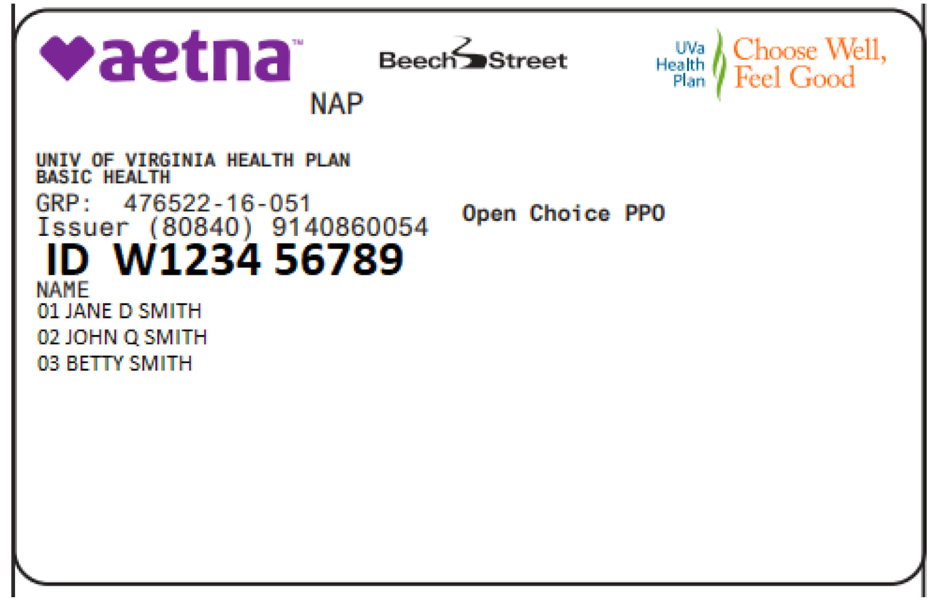

**Difference**

* With an HMO, or health maintenance organization plan, you pick one PCP under your plan’s network who provide routine care and refers you to in network specialists for additional care. HMOs will not cover out of network care.
* With a POS, or point-of-service plan, you also have one Primary care physician (PCP) who manages your access to other doctors. However, you can visit doctors out of network but it will cost more.
* With a PPO, or preferred provider organization plan, you don’t need a referral to seek additional care. You have more freedom to choose which doctors to see. But out of network will cost more.

|  |  |  |  |
| --- | --- | --- | --- |
| Plan Type | Network Coverage & Restrictions | Referrals | Out-of-Pocket Costs |
| HMO | Must stay in-network, except for emergencies | Typically required | Low |
| PPO | Flexible, but staying in-network will likely cost less | May not be required | High |
| EPO | Must stay in-network, except for emergencies | May not be required | Higher than HMO, lower than PPO |
| POS | Flexible, but staying in-network will likely cost less | Required | Higher than HMO and EPO, lower than PPO |

**HMO stands for “Health Maintenance Organization.”** HMO plans contract with doctors and hospitals creating a network to provide health services for members in a specific area at lower rates, while also meeting quality standards. HMO plans require you to select a primary care physician (PCP) and usually require a referral from your PCP to see a specialist or to have certain tests done. If you choose to see a provider outside of the HMO’s network, the plan will not cover those services and you will be responsible for all charges.

An **EPO means “Exclusive Provider Organization.”** This plan provides members with the opportunity to choose in-network providers within a broader network and to visit specialists without a referral from their primary care doctor. EPO plans offer a larger network than an HMO plan and typically do not have the out-of-network benefits of PPO plans. Generally, EPO plans cost more than an HMO, but less than a PPO.

**PPO stands for “Preferred Provider Organization.”** PPO plans are often more flexible when it comes to choosing a doctor or a hospital. These plans still include a network of providers, but there are fewer restrictions on the providers you choose. PPO plans do not require you to select a primary care physician (PCP), giving you a broader network of providers.

An example of comparing prices between HMO, PPO, and EPO is as follows:

For a family of four with a yearly income of $75,000, the estimated monthly premium costs for each plan might be:

* HMO: $400
* PPO: $600
* EPO: $550

In this example, the HMO plan offers the lowest monthly premium cost, but may have restrictions on accessing care and higher out-of-pocket costs for services not covered by the plan. The PPO plan offers more flexibility and a broader network of providers, but at a higher monthly premium cost. The EPO plan offers a balance between cost and network access, but with higher out-of-pocket costs for medical services.

**Q. Which plan should you choose?**

Each plan type has different benefits, so it depends on your health needs when choosing the right plan type. If you are looking for flexibility when choosing providers and locations, a PPO plan may better fit your needs. An EPO plan may be a better option if you travel often and want the flexibility of a larger network, but don’t necessarily need out-of-network benefits. If you regularly seek care in a certain geographic area and are looking for a health insurance plan at a lower price point, consider an HMO plan.

It is important to compare the different types of health insurance plans based on the individual's or family's specific healthcare needs and budget, in order to make the best choice.

**Copay**

A health insurance copayment is a fixed amount set by an insurance plan for sharing the cost of covered services between the plan and the customer. The cost-sharing system is a critical selling point for each plan because it breaks down how much you’ll actually owe for services, prescriptions, doctor visits, and more.

It’s important to understand the cost-sharing details of any health insurance plan you’re considering, especially for frequently used services or prescriptions. Keep in mind that these are out-of-pocket costs you’ll pay in addition to monthly premiums and costs for non-covered services.

Cost sharing primarily comes in three forms:

* **Copayment:** This is a fixed, flat fee for certain kinds of office visits, prescription drugs, or other services. Because the health insurance copay is fixed, you’ll know ahead of time exactly how much you owe. If your policy lists a copayment of $25 for a doctor visit, you pay that amount each time you see the doctor. It is also called eligible expense, payment allowance or negotiated rate.
* **Coinsurance:** This is a percentage of the total cost for a covered medical service, instead of a fixed copayment. If the insurance company owes a doctor $100 for your visit, and you have a coinsurance of 25 percent, you’ll pay $25 for the visit. You may pay it at the time of service or get a bill for your portion after the visit.
* **Annual deductible:** An annual deductible is a set amount that you may be required to pay toward covered medical care within a single year. For example, if you have a $3,000 annual deductible, you may need to pay that amount out of pocket toward covered medical care before the insurance company will begin paying your claims.

Generally, you’ll pay completely out of pocket for covered medical services until you reach your plan’s yearly deductible. After that, your insurance starts to pay for its share of costs, and you may owe a copayment or coinsurance for certain services as your “share.”

**Billing Provider**

Billing provider is an individual, agent, business, corporation, or other entity who, in connection with submission of claims to the Department, receives or directs payment from the Department on behalf of a performing provider and has been delegated the authority to obligate or act on behalf of the performing provider. Simply it’s an individual or entity enrolled in Medicaid that bills the department for services provided to a member.

**Rendering Provider**

A Rendering/Servicing provider is one who provides services through a Group, Facility, Agency, Organization or an Individual/Sole Proprietor.  A Rendering/Servicing provider does not bill directly to Michigan Medicaid. The Billing Provider that is associated to this applicant type, submits claims and receives payments for the Rendering/Servicing provider. This Billing Provider must be approved in CHAMPS (Community health automated Medicaid Processing System) prior to the submission of a new enrollment application for a Rendering/Servicing provider.

**Difference between Billing Provider and Rendering Provider**

In the context of medical billing, the "billing provider" and "rendering provider" refer to two different roles in the process of seeking reimbursement for medical services.  
  
The "billing provider" is the individual or organization responsible for submitting a claim to a payer (e.g. Medicare, Medicaid, private insurance) for payment for services rendered to a patient. The billing provider is typically the entity that has a direct financial relationship with the payer.  
  
The "rendering provider" is the individual or organization that actually provides the medical service to the patient. This could be a doctor, nurse, or other medical professional. The rendering provider may be different from the billing provider, as the medical service may be provided by one entity, but the billing and financial responsibilities may be handled by another entity.  
  
For example, a physician may work for a hospital, but bill for their services under their own name. In this case, the physician would be the rendering provider and the billing provider. The hospital would only be involved as the place where the service was rendered, but would not be responsible for billing the insurance company.

**Note:**

*The billing provider and rendering provider can be the same person. In healthcare, the billing provider is the individual or organization responsible for submitting a claim to insurance for reimbursement, while the rendering provider is the person who actually provides the service. If a single individual provides the service and submits the claim, they can be both the billing and rendering provider.*

**Provider Types**

Under federal regulations, a "health care provider" is defined as: a doctor of medicine or osteopathy, podiatrist, dentist, chiropractor, clinical psychologist, optometrist, nurse practitioner, nurse-midwife, or a clinical social worker who is authorized to practice by the State and performing within the scope of their practice as defined by State law.

**NPI**

The National Provider Identifier (NPI) is a Health Insurance Portability and Accountability Act (HIPAA) Administrative Simplification Standard. The NPI is a unique identification number for covered health care providers. It is issued by the National Plan and Provider Enumeration System-NPPES. It is a 10-digit numerical identifier that identifies an individual provider or a healthcare entity. An NPI number is shared with other providers, employers, health plans, and payers for billing purposes.

There are two type of NPI Providers

* **Type1 NPI:** Type1 individuals includes individuals, such as sole proprietors, dentists, physicians and surgeons. A provider is eligible for single NPI.
* **Type2 NPI:** Type2 NPI are organizations and may include acute care facilities, health systems, hospitals, physician groups, assisted living facilities and healthcare providers who are incorporated.

**CPT code**

CPT (Current Procedural Terminology) codes are codes used in the US healthcare system to describe medical procedures, services, and tests. They are five-digit numerical or alphanumeric codes used to identify specific procedures and services provided by healthcare providers to patients. CPT codes are standardized, which allows healthcare providers and insurance companies to understand and agree on the services rendered and the payment for those services. They play a crucial role in the medical billing and insurance reimbursement process.

**ICD**

ICD (International Classification of Diseases) codes are codes used in the US healthcare system to describe and classify diseases, disorders, symptoms, and other health conditions. They are standardized codes that allow healthcare providers and insurance companies to understand and agree on the diagnosis of a patient's health condition. The ICD codes are used for health management and health statistics, as well as for insurance reimbursement purposes. The most current version of ICD codes used in the US is the ICD-10, which was adopted in October 2015 and replaced the previous ICD-9 code set. The ICD codes are maintained and updated by the World Health Organization (WHO).

**Chapters**

The following table lists the chapter number using Roman Numerals, the code range of each chapter and the chapters

|  |  |  |
| --- | --- | --- |
| Chapter | Block | Title |
| I | A00–B99 | Certain infectious and parasitic diseases |
| II | C00–D48 | Neoplasms |
| III | D50–D89 | Diseases of the blood and blood-forming organs and certain disorders involving the immune mechanism |
| IV | E00–E90 | Endocrine, nutritional and metabolic diseases |
| V | F00–F99 | Mental and behavioral disorders |
| VI | G00–G99 | Diseases of the nervous system |
| VII | H00–H59 | Diseases of the eye and adnexa |
| VIII | H60–H95 | Diseases of the ear and mastoid process |
| IX | I00–I99 | Diseases of the circulatory system |
| X | J00–J99 | Diseases of the respiratory system |
| XI | K00–K93 | Diseases of the digestive system |
| XII | L00–L99 | Diseases of the skin and subcutaneous tissue |
| XIII | M00–M99 | Diseases of the musculoskeletal system and connective tissue |
| XIV | N00–N99 | Diseases of the genitourinary system |
| XV | O00–O99 | Pregnancy, childbirth and the puerperium |
| XVI | P00–P96 | Certain conditions originating in the perinatal period |
| XVII | Q00–Q99 | Congenital malformations, deformations and chromosomal abnormalities |
| XVIII | R00–R99 | Symptoms, signs and abnormal clinical and laboratory findings, not elsewhere classified |
| XIX | S00–T98 | Injury, poisoning and certain other consequences of external causes |
| XX | V01–Y98 | External causes of morbidity and mortality |
| XXI | Z00–Z99 | Factors influencing health status and contact with health services |
| XXII | U00–U99 | Codes for special purposes |

**ICD versions**

The US healthcare system uses the following versions of the International Classification of Diseases (ICD) codes:

**-ICD-9:** This was the previous version of the ICD codes used in the US until it was replaced by ICD-10 in October 2015.

**-ICD-10:** This is the current version of the ICD codes used in the US. It provides a more comprehensive and detailed system for classifying and describing diseases, disorders, symptoms, and other health conditions, and it includes expanded codes for medical and surgical procedures. The ICD-10 codes are used for insurance reimbursement purposes, health management and health statistics, and for tracking and monitoring trends in disease and health conditions.

* ICD-10-PCS- The procedure classification system developed by the Centers for Medicare & Medicaid Services (CMS) for use in the U.S. for inpatient hospital settings only. The new procedure coding system uses 7 alpha or numeric digits while the ICD-9-CM coding system uses 3 or 4 numeric digits.
* ICD-10-CM- The diagnosis classification system developed by the Centers for Disease Control and Prevention for use in all United States (U.S.) health care treatment settings. Diagnosis coding under this system uses 3–7 alpha and numeric digits and full code titles, and will be replacing the current ICD-9-CM code set.

**Q. Why we switch from ICD-9 to ICD-10?**

The switch from ICD-9 to ICD-10 was made because ICD-9 was becoming outdated and limited in its ability to classify modern medical practices and diseases. ICD-10 provides a more comprehensive and specific system for classifying diagnoses and procedures, which is important for accurate tracking and reporting of health information. This supports improved quality of care, research, and reimbursement purposes.

**Q. Is ICD-10-PCS different from CPT?**

Yes, ICD-10-PCS and CPT are different. ICD-10-PCS (Procedure Coding System) is used for classifying inpatient procedures, whereas CPT (Current Procedural Terminology) is used for classifying outpatient procedures. ICD-10-PCS is used in the United States for reporting hospital inpatient procedures, while CPT is used by physicians, health care facilities, and insurance companies for reporting medical procedures and services. Both codes provide a standardized system for reporting procedures, but they are separate and distinct systems.

**Q. If a procedure is being performed by the doctor and a CPT code is being used to represent the procedure, why does the procedure need to be translated into ICD-10-PCS for the hospital?**

Hospitals do not report inpatient procedures with CPT, like a physician does. They use a completely different coding system. On October 1, 2015, that coding system will be ICD-10-PCS. Therefore, procedures are will not be translated back and forth from CPT to ICD-10-PCS. If a procedure is performed as an inpatient procedure in a hospital AND the claim (a CMS 1450) is being submitted by the hospital, the code to describe the procedure would come from the ICD-10-PCS code set. The surgeon will submit a CMS 1500 claim to 3rd party payers and that claim will contain CPT procedure codes.

**Q. What ICD-10 codes are billable?**

ICD-10 codes that are billable are those codes that accurately describe the diagnosis, symptoms, or medical condition of a patient and that are used to support a claim for payment by a healthcare provider. The codes must meet the requirements of the specific payer, including meeting medical necessity criteria and not being considered experimental or investigational.  
  
For example, if a patient is diagnosed with Type 2 diabetes, the billable ICD-10 code for that diagnosis would be E11.9 (Type 2 diabetes mellitus without complications). This code accurately describes the patient's condition and can be used to support a claim for payment from the patient's insurance company.  
  
It's important to note that while this code may be considered billable by one insurance company, another company may have different requirements or limitations on coverage. Therefore, it's important for healthcare providers to check with the patient's insurance plan to confirm which ICD-10 codes are billable for that particular patient.

**Q. How many ICD-10 Combinations are there?**

As with ICD-9-CM, ICD-10-CM is maintained by the National Center for Health Statistics. The system consists of **more than 68,000** codes, compared to approximately 13,000 ICD-9-CM codes.

**Note:** The World Health Organization (WHO) updates the ICD codes periodically and releases new versions. The US healthcare system is expected to adopt future versions of the ICD codes as they become available. In 2023 1176 New code are added in ICD-10.

**Q. What are Header Codes?**

These codes are identified by CDC (Centers for Disease Control and Prevention) as **Header Codes** which are not valid for HIPAA transactions or considered proper coding. There are about 70,000 HIPAA-valid ICD-10 codes. And there are approximately 22,000 additional header codes. Header codes require more digits to indicate the appropriate level of specificity. The increased level of specificity is expected to provide significantly better data analysis opportunities for the health-care industry.

We will deny header codes with the following CORE (Committee on Operating Rules for Information Exchange) approved messages:

* **Claim Adjustment Reason Code (CARC) 16:** Claim/service lacks information or has submission/billing error(s) which is needed for adjudication.
* **Remittance Advice Remark Code (RARC) M76:** Missing/incomplete/invalid diagnosis or condition.

**Example:**

Z34-Encounter for supervision of normal pregnancy—**Header Code**

Z340-Encounter for supervision of normal first pregnancy—**Header Code**

Z3400-Encounter for supervision of normal 1st pregnancy. Unspecified Trimester—**Unspecified Code**

Z3401- Encounter for supervision of normal 1st pregnancy.1st trimester—**ICD-10**

**Q. What is the relation between ICD and CPT in US healthcare system**

* ICD (International Classification of Diseases) codes and CPT (Current Procedural Terminology) codes are two different coding systems used in the US healthcare system.
* ICD codes are used to describe and classify diseases, disorders, symptoms, and other health conditions for health management and health statistics, as well as for insurance reimbursement purposes.
* CPT codes, on the other hand, are used to describe medical procedures, services, and tests provided by healthcare providers to patients. They are used for billing and insurance reimbursement purposes, and help to standardize the description of the services rendered so that healthcare providers and insurance companies can understand and agree on the services provided and the payment for those services.

**Q. What is ICD-9 and ICD-10 mapping?**

Mapping tables provide a link between two editions of a classification. Mapping develops links between concepts within one data set (e.g., a classification or terminology) to the same or substantially similar concepts in another data set. The purpose for the map is called its use case. The map between ICD-9-CM and CPT is bidirectional, meaning that concepts can be translated in any direction. The map provides links between procedure codes in the one coding system to procedure codes used to represent the same or similar procedures in the coding system.

**For example**, from [ICD10Data.com](https://www.icd10data.com/Convert/250.00) You can check the mapping like ICD-9-CM 250.00 is equals to ICD-10-CM E11.9 **Type 2 diabetes mellitus without complications**.

ICD-10-CM Z48.3 converts directly to 2015 ICD-9-CM V58.42 **Aftercare following surgery for neoplasm** (An abnormal mass of tissue that forms when cells grow and divide more than they should or do not die when they should).

The two coding systems are related because they both play a role in the medical billing and insurance reimbursement process. For example, when a patient receives a medical service or procedure, the healthcare provider will use both an ICD code to describe the patient's diagnosis and a CPT code to describe the service or procedure provided. The combination of the ICD and CPT codes is used to determine the payment for the service or procedure.

Q. What are bits in header codes?

The header code refers to the first three characters of an ICD code, which provide general information about the category of the diagnosis or procedure.

Bits in header codes refers to the specific digit or letter that occupiers a particular position in the header code. For example, in the ICD-10-CM code B20 for HIV disease, the header code is “B20”, and the “B” is the first bit, “2” is the second bit, and “0” is the third bit.

The value of a bit depends on its position and context within the code. For example, in the B20 code, the "B" indicates the category of the diagnosis (infectious and parasitic diseases), while the "2" indicates the specific disease (HIV disease) within that category. The "0" has no specific meaning in this code but is needed to complete the three-character header.

**HCPCS**

HCPCS (Healthcare Common Procedure Coding System) is a coding system used in the US healthcare system to describe medical procedures, services, and supplies, as well as durable medical equipment (DME) and other medical equipment used in the diagnosis and treatment of patients.  
  
HCPCS codes are similar to CPT (Current Procedural Terminology) codes and are used for billing and insurance reimbursement purposes. HCPCS codes provide a standardized way for healthcare providers and insurance companies to describe and understand the medical services, supplies, and equipment provided to patients. The HCPCS codes are maintained and updated by the Centers for Medicare & Medicaid Services (CMS) and are used primarily for billing Medicare and Medicaid programs, but may also be used by private insurance companies and other healthcare payers.  
  
The HCPCS coding system is divided into two levels, Level I and Level II. Level I HCPCS codes are comprised of CPT codes, which are maintained by the American Medical Association (AMA), and are used to describe medical procedures and services. Level II HCPCS codes are used to describe medical supplies, equipment, and other services that are not included in the CPT codes. Level II HCPCS codes are updated annually and provide additional detail and specificity compared to Level I codes.

**Dx Pointers**

Dx pointers, also known as diagnosis pointers, are used in the US healthcare system to indicate the relationship between a medical procedure or service and the patient's diagnosis. Dx pointers are used in medical billing and insurance reimbursement processes to help healthcare providers and insurance companies understand the context of the medical service provided to the patient.  
  
**For example,** when a healthcare provider submits a claim to an insurance company for a medical procedure, they would include both the CPT (Current Procedural Terminology) code for the procedure and the ICD (International Classification of Diseases) code for the patient's diagnosis. The Dx pointer is a letter or symbol used to indicate the relationship between the two codes.  
  
**For example,** if a patient is diagnosed with a broken arm (ICD code S52.02) and undergoes a cast application procedure (CPT code 29515), the Dx pointer would indicate that the cast application procedure is being performed to treat the broken arm. The Dx pointer would be included in the claim submitted to the insurance company to help them understand the context of the medical service being provided.  
  
**Note:** The specific Dx pointers used in the US healthcare system may vary depending on the medical billing and insurance reimbursement processes used by different healthcare providers and insurance companies.

**Accept Assignment**

Accept assignment in the US healthcare system refers to a healthcare provider's agreement to accept the Medicare-approved amount as payment in full for services provided to a Medicare beneficiary. When a healthcare provider accepts assignment, they agree to accept the Medicare payment as payment in full, and cannot bill the patient for any additional amounts.  
  
**For example**, if a healthcare provider provides a service to a Medicare beneficiary and the Medicare-approved amount for that service is $100, the healthcare provider who accepts assignment would bill Medicare for $100 and accept that payment as payment in full for the service provided. The healthcare provider cannot bill the patient for any additional amounts.  
Accept assignment is an important concept in the US healthcare system because it helps to ensure that Medicare beneficiaries receive their medical services at a predictable cost, and that healthcare providers are paid fairly and consistently for their services. Healthcare providers who do not accept assignment may charge patients more than the Medicare-approved amount, which can lead to unexpected out-of-pocket costs for the patient.

**Modifiers**

Modifiers in the US healthcare system are two-digit codes added to CPT (Current Procedural Terminology) codes to provide additional information about a medical service or procedure. Modifiers are used to describe specific aspects of a medical service that may affect the payment for that service, such as the circumstances under which the service was provided, the location of the service, or the type of service provided.  
  
**For example,** if a healthcare provider performs a procedure with a CPT code of 99201, but the patient has multiple medical conditions that require additional time and effort on the part of the healthcare provider, the healthcare provider may add modifier 25 to the CPT code. Modifier 25 indicates that a significant, separately identifiable evaluation and management (E/M) service was provided on the same day as a procedure, and may result in a higher payment for the service provided.  
  
Another example of a modifier is modifier 59, which is used to indicate that a service was distinct or separate from other services performed during the same encounter. For example, if a healthcare provider performs two procedures during the same visit, but the procedures are not typically performed together and are separately billable, the healthcare provider may add modifier 59 to one of the CPT codes to indicate that the service is distinct or separate.

For example, a patient may be diagnosed with chronic obstructive pulmonary disease (COPD) and receive a bronchoscopy procedure. The ICD code for COPD is J44.9 and the CPT code for the bronchoscopy procedure is 31623. However, if during the bronchoscopy procedure the physician performs a biopsy, the modifier -59 (Distinct Procedural Service) would be added to the CPT code to indicate that a separate, distinct service was performed. The modified code would be 31623-59.  
  
*Modifiers play an important role in the US healthcare system by providing additional information about medical services that can affect payment for those services. This information helps insurance companies and other healthcare payers make more informed decisions about reimbursement for medical services, and helps ensure that healthcare providers are paid fairly and consistently for the services they provide.*

**Clearing Houses**

Clearinghouses in the US healthcare system are intermediaries between healthcare providers and insurance companies that process and manage medical claims. They are responsible for verifying the validity of the claims, ensuring that the codes and information used on the claims are accurate, and transmitting the claims to the insurance companies for payment. There are two types of clearinghouses:  
  
**Web-based clearinghouses** - These clearinghouses are web-based platforms that allow healthcare providers to submit electronic claims directly to insurance companies.  
  
**Data-based clearinghouses** - These clearinghouses collect and aggregate medical claims from multiple healthcare providers, and then transmit the claims to insurance companies for payment.  
  
An example of a clearinghouse is Change Healthcare. Change Healthcare is a data-based clearinghouse that receives claims from healthcare providers, validates the claims, and transmits them to insurance companies for payment. The clearinghouse uses advanced technologies such as artificial intelligence and machine learning to ensure the accuracy and efficiency of the claims processing. The healthcare providers receive feedback on the status of their claims and receive payments from insurance companies through the clearinghouse. for example, if a patient fills out forms as Jenny but their full legal name is Jennifer, the clearing houses make sure those records get combined and not added as a new patient. They will also check for duplicate or incorrect codes that tell the system what to bill for.

**Q. How does a Medical billing Clearing house work?**

When healthcare providers install medical billing software, each claim becomes a file knows as an **ANSI-X12-837**. Each file is then uploaded to the clearing house and scrubbed for errors. Finally, the error-free file is transmitted to the insurance company for processing. This entire process takes place over secure electronic connections per the guidelines of the HIPPA.

**Q. What are the benefits of using a medical billing clearing house?**

There are many advantages to using a medical billing clearinghouse for your claims process. Here are just a few key benefits that come from leveraging this option:

* Greater Convenience
* Better Legibility
* Improved Processes
* Increased Administrative Efficiency
* More Accurate Documentation
* Fewer Errors and returned claims
* Improved ROI

Clearinghouses play a crucial role in the US healthcare system by serving as intermediaries between healthcare providers and insurance companies. They process and manage the large volume of administrative and financial transactions involved in submitting and paying health insurance claims. Clearinghouses help ensure that claims are accurate, standardized, and comply with industry standards and regulations, making the claims process more efficient and reducing errors and delays in payment. They also provide data analytics and other value-added services to healthcare providers, insurance companies, and government agencies to help improve the overall functioning of the healthcare system.

**Q. Why do we need Clearing houses?**

* Clearing house software can identify errors in seconds and alert your staff immediately. Which allows them to quickly adjust while the information is still fresh in their mind.
* A clearing house stores individual payer information so that data related to that payer doesn’t have to be re-entered every single time, making the submission process much faster.
* You have the option to send all your claims at once instead of submitting a separate file for each and every payer.
* In the case of an emergency event, a clearing house can provide you with a back-up copy of any important billing data you submitted and then lost.
* You save money on printing ink, stamps, mailing supplies and other expenses associated with paper correspondence.

**Patient Demographics**

Patient demographics are a patient’s basic information. Practices collect patient demographics to provide higher-quality care and streamline the [medical billing and coding](https://www.businessnewsdaily.com/16238-medical-billing-coding.html) process. These data overlap strongly with [marketing demographics](https://www.businessnewsdaily.com/15779-small-business-marketing-demographics.html), though they aren’t exactly the same. Whereas marketers use demographics to determine which consumers might be worth their attention, practitioners use patient demographics to help those already in front of them and bill payers for their services.

Patient demographics almost always include the following information:

* Full legal name
* Date of birth
* Biological sex
* Gender
* Contact information, including address
* Ethnicity
* Race
* Allergies
* Previous medical history
* Insurance ID number
* SSN

**Q- Why are Patient demographics important?**

Patient demographics matter because they:

* Guide the billing process
* Streamline patient communications
* Improve patient care
* Increase Cultural Competency

**EDI**

Electronic Data Interchange (EDI) is the electronic exchange of standardized business documents between companies in the US healthcare system. It is used to facilitate the transaction of information between healthcare providers, insurance companies, and government agencies.  
  
Some of the common EDI transactions in the US healthcare system include:

* **Healthcare claim transaction set (837)**. It allows healthcare providers and patients to submit healthcare claim information and encounter information.
* **Retail pharmacy claim transaction**. It allows healthcare professionals and regulatory agencies to submit retail pharmacy claims. It also lets them transmit claims for retail pharmacy services and billing payment information to payers.
* **Healthcare claim payment/advice transaction set (835)**. It is used by insurers to make payments and send Explanation of Benefits (EOB) remittance advice to healthcare providers.
* **Benefits enrollment and maintenance set (834)**. It is used by employers, unions, government agencies, insurance agencies, associations, or healthcare organizations paying claims. Its aim is to enroll members in a healthcare benefit plan.
* **Payroll deducted and other group premium payment for insurance products (820)**. This transaction serves to make premium payments for insurance products and is used by healthcare institutions to send information to financial organizations.
* **Healthcare eligibility/benefit inquiry (270)**. This transaction set is used by healthcare institutions to transmit inquiries for healthcare benefits and subscriber eligibility to financial institutions and government agencies.
* **Healthcare eligibility/benefit response (271)**. Its main purpose is to respond to request inquiries about the healthcare benefits and eligibility associated with a subscriber or dependent. Like the previous transaction, it is used by healthcare institutions to transmit information to financial institutions and government agencies.
* **Healthcare claim status request (276)**. This transaction is used by healthcare providers to request or verify the status of healthcare previously submitted to a payer, such as an insurance company.
* **Healthcare claim status notification (277)**. It serves for reporting on the status of claims (EDI 837 transactions) previously submitted by providers. EDI 277 is used by healthcare payers and insurance companies.
* **Healthcare service review Information (278)**. It is used by hospitals to request an authorization from a payer, such as an insurance company.

The EDI transactions list also includes EDI Functional Acknowledgement Transaction Set (997). But it doesn’t cover any semantic meaning of the information encoded in the transaction sets. It is only necessary for X12 transaction set processing.

**Segments**

If you were filling out information on a purchase order, you would expect to see groups of related data. For example, look at the diagram below of a paper purchase order in which only one item is being ordered. Note that there are four sections, each providing a different set of information:

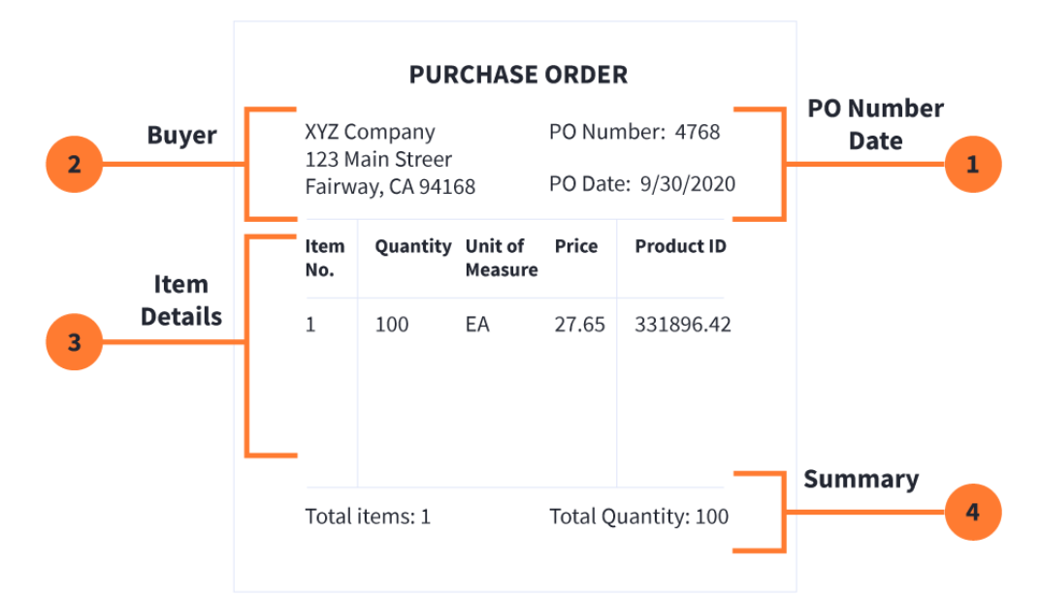

The graphic below shows a sample purchase order in printed form and how it would look once it’s translated into the [**ANSI**](https://www.edibasics.com/edi-resources/document-standards/ansi/)and [**EDIFACT**](https://www.edibasics.com/edi-resources/document-standards/edifact/)EDI formats.

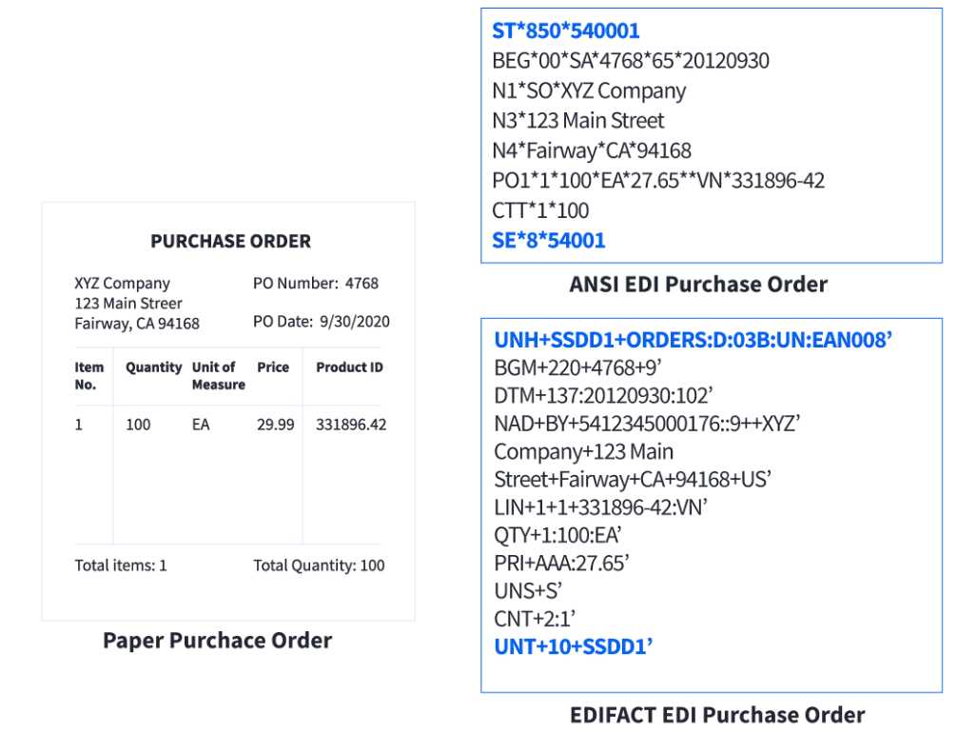

**Q. What’s the difference between 837P and 837I?**

* EDI P (Professional) refers to EDI transactions that are used to submit claims for payment to insurance companies or Medicare/Medicaid from Physicians, suppliers and non-institutional providers for both in-patient and out-patient
* EDI I (Institutional) refers to EDI transactions that are used to submit claims for payment from institutional providers, such as hospitals or long-term care facilities, to insurance companies or Medicare/Medicaid.

**Q. What is Pre-Authorization in EDI?**

Pre-authorization in EDI refers to the process of obtaining approval from a payer (such as an insurance company) for a proposed healthcare service or treatment before it is performed. The goal of pre-authorization is to ensure that the proposed service is medically necessary and covered by the patient's insurance policy, and to estimate the cost of the service so that the patient and the healthcare provider are aware of any out-of-pocket expenses that may be incurred.

An example of pre-authorization using EDI:

* A healthcare provider evaluates a patient and determines that a specific medical procedure is necessary.
* The provider uses the EDI 278 transaction to submit a request for pre-authorization of the medical procedure to the patient's insurance company. The request includes information such as the patient's demographic information, diagnosis codes, and the proposed treatment plan.
* The insurance company reviews the information and uses the EDI 278 transaction to respond to the provider with the results of the pre-authorization review. The response may include information such as whether the medical procedure has been approved or denied, any conditions that must be met for approval, and the estimated cost of the procedure.
* If the medical procedure is approved, the healthcare provider can proceed with the treatment, confident that it will be covered by the patient's insurance policy. If the procedure is denied, the provider and patient can work together to determine alternative courses of action.

**Q. What’s the difference between 278I and 278N?**

Two common variants of the EDI 278 transaction are the 278I (Information Only Request) and the 278N (Request for Approval or Denial of Services).

The 278I is used to request general information about a healthcare service, such as the coverage criteria, policies, and procedures for pre-authorization. The 278I is typically used by healthcare providers to gain a better understanding of the payer's requirements and processes for pre-authorizing healthcare services.

The 278N, on the other hand, is used to request specific approval or denial of a proposed healthcare service. The 278N includes all the necessary information about the proposed service, including patient demographic information, diagnosis codes, and the proposed treatment plan. The payer reviews the information in the 278N and uses the EDI 278 transaction to respond with the results of the review, including whether the service has been approved or denied, any conditions that must be met for approval, and the estimated cost of the service.

In summary, the 278I is used to request general information, while the 278N is used to request specific approval or denial of a proposed healthcare service.

**Q. What’s the difference between Referral, Authorization???**

In the US healthcare system, referral, authorization, and pre-authorization are terms that describe different aspects of the process of obtaining approval for healthcare services.

Here's a brief explanation of each term, along with an example:

* Referral: A referral is a recommendation from one healthcare provider to another, indicating that a patient needs to be seen by a specialist or receive a specific type of care. For example, a primary care physician may refer a patient to a specialist for a specific medical condition.
* Authorization: Authorization refers to the process of obtaining approval from a payer (such as an insurance company) for a proposed healthcare service or treatment. This process confirms that the service is medically necessary and covered by the patient's insurance policy, and also provides the patient and healthcare provider with an estimate of the cost of the service.

An example of the referral, authorization, and pre-authorization process:

* A patient sees their primary care physician, who determines that the patient needs to see a specialist for a specific medical condition.
* The primary care physician refers the patient to a specialist using the EDI 278 transaction.
* The specialist uses the EDI 278 transaction to submit a request for pre-authorization of a specific medical procedure to the patient's insurance company.
* The insurance company reviews the information in the EDI 278 transaction and uses the EDI 278 transaction to respond with the results of the pre-authorization review, including whether the service has been approved or denied, any conditions that must be met for approval, and the estimated cost of the service.
* If the medical procedure is approved, the specialist proceeds with the treatment, confident that it will be covered by the patient's insurance policy.

**Q. What’s the difference between PAN and Referral?**

In the US healthcare industry, a PAN (Pre-Authorization Number) and a referral are two different concepts that are used to manage patient care and determine reimbursement for healthcare services.

A PAN is a unique number assigned by a payer, such as an insurance company, to pre-approve a specific healthcare service or treatment for a patient. The purpose of a PAN is to ensure that the patient's insurance coverage will be honored for the specific service, and to confirm that the service is medically necessary and meets the criteria for coverage under the patient's insurance plan.

For example, if a patient requires a costly medical procedure, the provider may need to obtain a PAN from the patient's insurance company in order to confirm that the procedure is covered and that the patient will not be responsible for the full cost of the service.

A referral, on the other hand, is a process by which a healthcare provider refers a patient to another provider or specialist for a specific service or treatment. The purpose of a referral is to ensure that the patient receives the appropriate level of care for their specific needs, and to coordinate the care that is provided to the patient.

For example, if a patient has a complex medical condition that requires the expertise of a specialist, the primary care provider may refer the patient to a specialist for further evaluation and treatment.

In summary, a PAN is used to pre-approve a specific service for coverage, while a referral is used to refer a patient to another provider for a specific service or treatment. Both concepts are important in the US healthcare industry, and are used to manage patient care and ensure that patients receive the appropriate level of care for their specific needs.

EDI helps streamline the healthcare claims process and reduces errors and delays associated with manual data entry and processing. It also ensures that sensitive patient information is securely transmitted between healthcare stakeholders.

There are several EDI protocols and communication standards used in the US healthcare system. Some of the most common ones are:

* **ANSI X12:** This is a widely used EDI standard that was developed by the Accredited Standards Committee (ASC) X12. It covers a wide range of EDI transactions including claims submissions, remittance advice, eligibility and benefit inquiries, and more.  
  **Example:** The ANSI X12 837 is used to submit healthcare claims electronically.
* **NCPDP:** Developed by the National Council for Prescription Drug Programs, NCPDP is used for EDI transactions related to pharmacy claims, drug benefits, and prescription orders.  
  **Example:** The NCPDP Telecommunication Standard is used to electronically transmit pharmacy claims information.
* **HL7:** This standard was developed by the Health Level Seven International and is used for the exchange of health information between healthcare providers and other stakeholders.  
  **Example:** The HL7 2.x series is used to transfer clinical and administrative data between healthcare organizations.
* **EDIFACT:** This is an international EDI standard developed by the United Nations and is used in several countries outside of the US.

**Example:** The EDIFACT INVOIC is used to send invoices electronically between business partners.  
  
The use of these standardized protocols ensures that EDI transactions are consistent, reliable, and secure, and helps reduce the risk of errors and delays in the healthcare claims process.

**Q. What’s the difference between EDIFACT and ANSI?**

ANSI (American National Standards Institute) and EDIFACT (Electronic Data Interchange for Administration, Commerce and Transport) are two standardized formats that are used for the electronic exchange of information between organizations.

ANSI is a non-profit organization that develops and publishes standards in a variety of industries, including healthcare. In the healthcare industry, ANSI has developed the ANSI X12 standard, which is a set of electronic data interchange (EDI) standards that are used to transmit information between healthcare organizations. The ANSI X12 standard includes specific data elements and codes that are used to transmit information such as claims, remittances, and enrollments.

EDIFACT, on the other hand, is an international EDI standard that is used for the electronic exchange of information between organizations in a variety of industries, including healthcare. EDIFACT defines the format and structure of EDI transactions and includes specific data elements and codes that are used to transmit information such as purchase orders, invoices, and shipping notices.

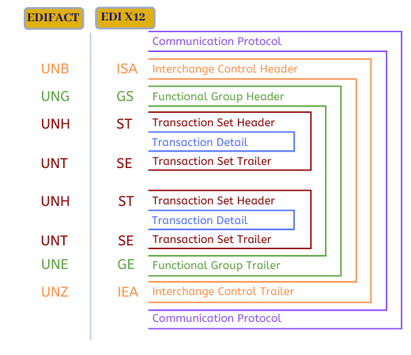

In summary, ANSI and EDIFACT are two standardized formats that are used for the electronic exchange of information between organizations. ANSI has developed the ANSI X12 standard for the healthcare industry, while EDIFACT is an international EDI standard that is used in a variety of industries, including healthcare.

**HCFA 1500**

The HCFA (Health Care Financing Administration) 1500 is a standardized form used for submitting medical claims in the United States. The form, which is also known as the CMS-1500, is used by healthcare providers to bill insurance companies for medical services provided to patients.  
  
The HCFA 1500 form contains key information about the patient, including their name, date of birth, and insurance information, as well as information about the services provided, such as diagnosis codes and treatment codes. The form also includes a section for the provider to specify the charges for each service.  
  
The HCFA 1500 form has been replaced by the newer CMS-1500 form, which is similar in content but has been updated to reflect changes in medical coding and billing practices.  
  
Here is an example of how the HCFA 1500 form could be used in a typical healthcare scenario:  
  
A patient visits a doctor for treatment of a medical condition. The doctor provides a diagnosis and treatment, and the patient's insurance information is obtained. The doctor's office then uses the HCFA 1500 form to bill the insurance company for the services provided. The form is filled out with the patient's information, the diagnosis and treatment codes, and the charges for each service. The completed form is then submitted to the insurance company for payment.  
  
The use of the HCFA 1500 form helps streamline the medical billing process by providing a standardized format for submitting claims, and reduces the risk of errors and delays in payment.

**ERA**

Electronic Remittance Advice (ERA) is a type of electronic document used in the US healthcare system to communicate payment information from insurance companies to healthcare providers. It is generated after an insurance company processes a claim submitted by a provider and contains information about the payments made and any adjustments or denials made to the claim.  
  
The ERA provides a detailed breakdown of the claim, including the allowed amount, the amount paid, and the patient's responsibility, if any. It also includes information about any deductibles, coinsurance, and copayments, as well as any explanations of benefits (EOBs) or reasons for adjustments or denials.  
  
Here is an example of how ERA could be used in a typical healthcare scenario:  
  
A healthcare provider submits a claim to an insurance company for services provided to a patient. The insurance company processes the claim and generates an ERA. The ERA is transmitted electronically to the provider and includes information about the payment made, any adjustments or denials, and any remaining patient responsibility. The provider can use this information to reconcile their accounts and ensure that they have received the correct payment for the services provided.  
  
The use of ERA helps streamline the medical billing process and reduces the need for manual reconciliation of payments, as well as improves accuracy and reduces errors in the process.

**EOB**

An Explanation of Benefits (EOB) is a document used in the US healthcare system to provide information about the payment made by an insurance company for a medical claim. The EOB serves as a detailed breakdown of the insurance company's payment and includes information about any deductibles, coinsurance, copayments, and other charges.  
  
The EOB is typically sent to the patient or the healthcare provider after the insurance company processes a claim. It provides a clear understanding of the charges and the payment made, and helps both the patient and the provider keep track of their financial obligations and responsibilities.

Here is an example of how an EOB could be used in a typical healthcare scenario:

A patient visits a doctor and receives medical treatment. The doctor's office submits a claim to the insurance company for payment. After processing the claim, the insurance company generates an EOB and sends it to the patient. The EOB shows the charges for the medical services provided, the amount covered by the insurance, and any amounts owed by the patient, such as copayments, deductibles, or coinsurance.  
  
The use of EOB helps increase transparency and clarity in the medical billing process, enabling patients and healthcare providers to understand their financial obligations and responsibilities. It also helps reduce the risk of misunderstandings and disputes related to payment.

***Electronic remittance advice (ERA) is an electronic version of the explanation of benefits (EOB) for claims payments***

ERA (Electronic Remittance Advice) is a type of electronic payment advice generated by insurance companies to healthcare providers. It provides details about insurance payments for medical claims submitted by healthcare providers and helps the providers reconcile their payments and patient billing.

EOB (Explanation of Benefits) is a document provided by insurance companies to policyholders explaining the details of a particular claim and how the insurance company has processed and paid it. The EOB explains what was covered, what was denied, and the reasons why. It also shows how much the policyholder is responsible for paying and how much was paid by the insurance company.

***In summary, ERA is a document for healthcare providers, while EOB is a document for policyholders.***

**Q. Do EOB have a number?**

The EOB typically includes a unique identifier that is assigned by the payer, such as a claim number, a reference number, or a policy number. This number is used to identify the specific transaction and to track the payment.

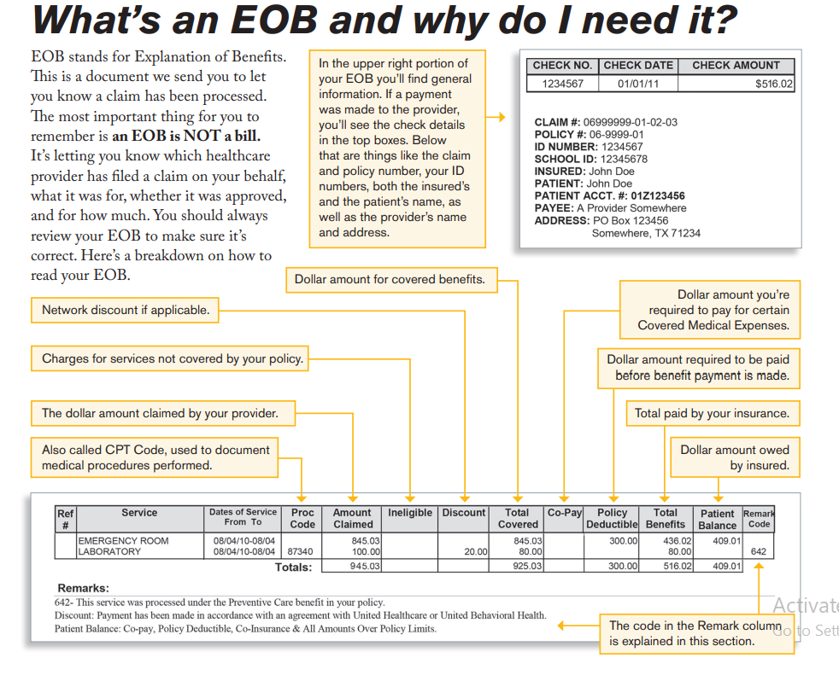

**Eligibility**

Eligibility in the US healthcare system refers to a patient's ability to receive medical benefits under a particular insurance plan. Eligibility determines whether a patient is covered for specific medical services, and it is based on a variety of factors, such as the patient's age, location, and enrollment status in an insurance plan.  
  
Eligibility is an important aspect of the healthcare system because it determines a patient's access to medical care and helps healthcare providers understand the extent of a patient's insurance coverage. It is used to determine whether a patient's insurance plan will pay for a particular medical service and whether the patient will be responsible for paying any deductibles, coinsurance, or copayments.  
  
Here is an example of how eligibility could be used in a typical healthcare scenario:  
  
A patient visits a doctor and needs a specific medical test. The doctor's office checks the patient's insurance plan to determine their eligibility for the test. The office then submits a claim to the insurance company for payment. The insurance company checks the patient's eligibility and determines whether the test is covered under the patient's insurance plan and how much the patient will be responsible for paying. If the patient is eligible for the test, the insurance company pays the claim, and the patient is responsible for paying any copayments, deductibles, or coinsurance.  
  
The use of eligibility helps ensure that patients have access to the medical care they need and helps healthcare providers understand the extent of a patient's insurance coverage. It also helps prevent misunderstandings and disputes related to payment and helps ensure that patients receive the correct medical treatment.

**5010 Standard**

The 5010 standard is a version of the electronic data interchange (EDI) standard used in the US healthcare industry for the exchange of electronic transactions between healthcare providers and insurance companies. It is the successor to the 4010 standard and was introduced to improve the efficiency and accuracy of electronic transactions in the healthcare industry.  
  
The 5010 standard specifies the format and content of electronic transactions, such as claims submissions, remittance advice, and eligibility requests. It includes specific requirements for data elements, code sets, and transaction structure. The 5010 standard ensures that electronic transactions are processed accurately, efficiently, and consistently, reducing the risk of errors, delays, and denied claims.  
  
Here is an example of how the 5010 standards could be used in a typical healthcare scenario:  
  
A healthcare provider submits a claim to an insurance company for payment. The provider uses the 5010 standard to format the electronic transaction, including all the required data elements and code sets. The insurance company receives the claim and processes it using the 5010 standard, which ensures that the transaction is processed accurately, efficiently, and consistently. The insurance company then generates a remittance advice, which is also formatted using the 5010 standard, and sends it back to the provider.

**Q. What’s the difference between 5010 and 4010 standard in US healthcare system?**

The 5010 and 4010 standards refer to versions of the Electronic Data Interchange (EDI) format used for exchanging health care claims information between health care providers and payers. The EDI format is a set of standardized codes and data elements that are used to electronically transmit information such as claims, remittances, and eligibility inquiries.

5010 is the latest version of the EDI format and replaces the previous 4010 standard. The 5010 standard provides increased data accuracy and increased capacity to handle larger and more complex transactions compared to 4010. It also includes updates to existing codes and data elements and the addition of new codes and data elements to accommodate changes in the healthcare industry.

Here are a few specific examples of the differences between 5010 and 4010:

* **Data field size:** In 5010, the size of some data fields has been increased, allowing for more detailed information to be transmitted electronically. For example, the patient's name field size has been increased from 26 characters in 4010 to 60 characters in 5010.
* **New codes and data elements:** 5010 include new codes and data elements, such as the National Provider Identifier (NPI) code, which is used to identify health care providers in the United States. The NPI code is a unique 10-digit identifier that is used in place of legacy provider identification numbers, such as the UPIN or Medicare Provider Number.
* **Enhanced security:** 5010 includes enhancements to the security of electronic transactions, such as the use of digital signatures to ensure the authenticity and integrity of the transmitted data.
* **Improved transaction processing:** 5010 provides improved transaction processing capabilities, including the ability to process claims with multiple service lines and multiple service dates, as well as the ability to process claims for Durable Medical Equipment (DME) and Home Health Services.

It is important to note that 5010 is mandatory for all covered entities, including health care providers and payers, as of January 1, 2012. The 4010 standard is no longer used for new transactions and is only supported for the resolution of outstanding claims or to support limited legacy systems.

In summary, the 5010 standard provides improvements in the accuracy, security, and processing capabilities of electronic health care transactions compared to the 4010 standard.  
  
The use of the 5010 standard helps improve the efficiency and accuracy of electronic transactions in the healthcare industry and reduces the risk of errors, delays, and denied claims. It ensures that all stakeholders in the healthcare system, including healthcare providers, insurance companies, and patients, have access to accurate and up-to-date information.

**Patient Statement**

A patient statement in the US healthcare industry is a document that provides a summary of the financial transactions between a patient and a healthcare provider. It typically includes information about the medical services provided, the amounts charged, and any payments made by the patient or by insurance companies. The patient statement is used to communicate the patient's financial obligations and helps the patient understand the charges for their medical treatment.  
  
Here is an **example** of how a patient statement could be used in a typical healthcare scenario:  
A patient visits a doctor and receives medical treatment. The doctor's office generates a bill and submits a claim to the insurance company for payment. The insurance company processes the claim and makes a payment, which is reflected on the patient's statement. The patient statement shows the charges for the medical services provided, the amount covered by the insurance, and any amounts owed by the patient, such as copayments, deductibles, or coinsurance.

The use of patient statements helps increase transparency and clarity in the medical billing process, enabling patients to understand their financial obligations and responsibilities. It also helps reduce the risk of misunderstandings and disputes related to payment and helps ensure that patients receive accurate and up-to-date information about their financial status.

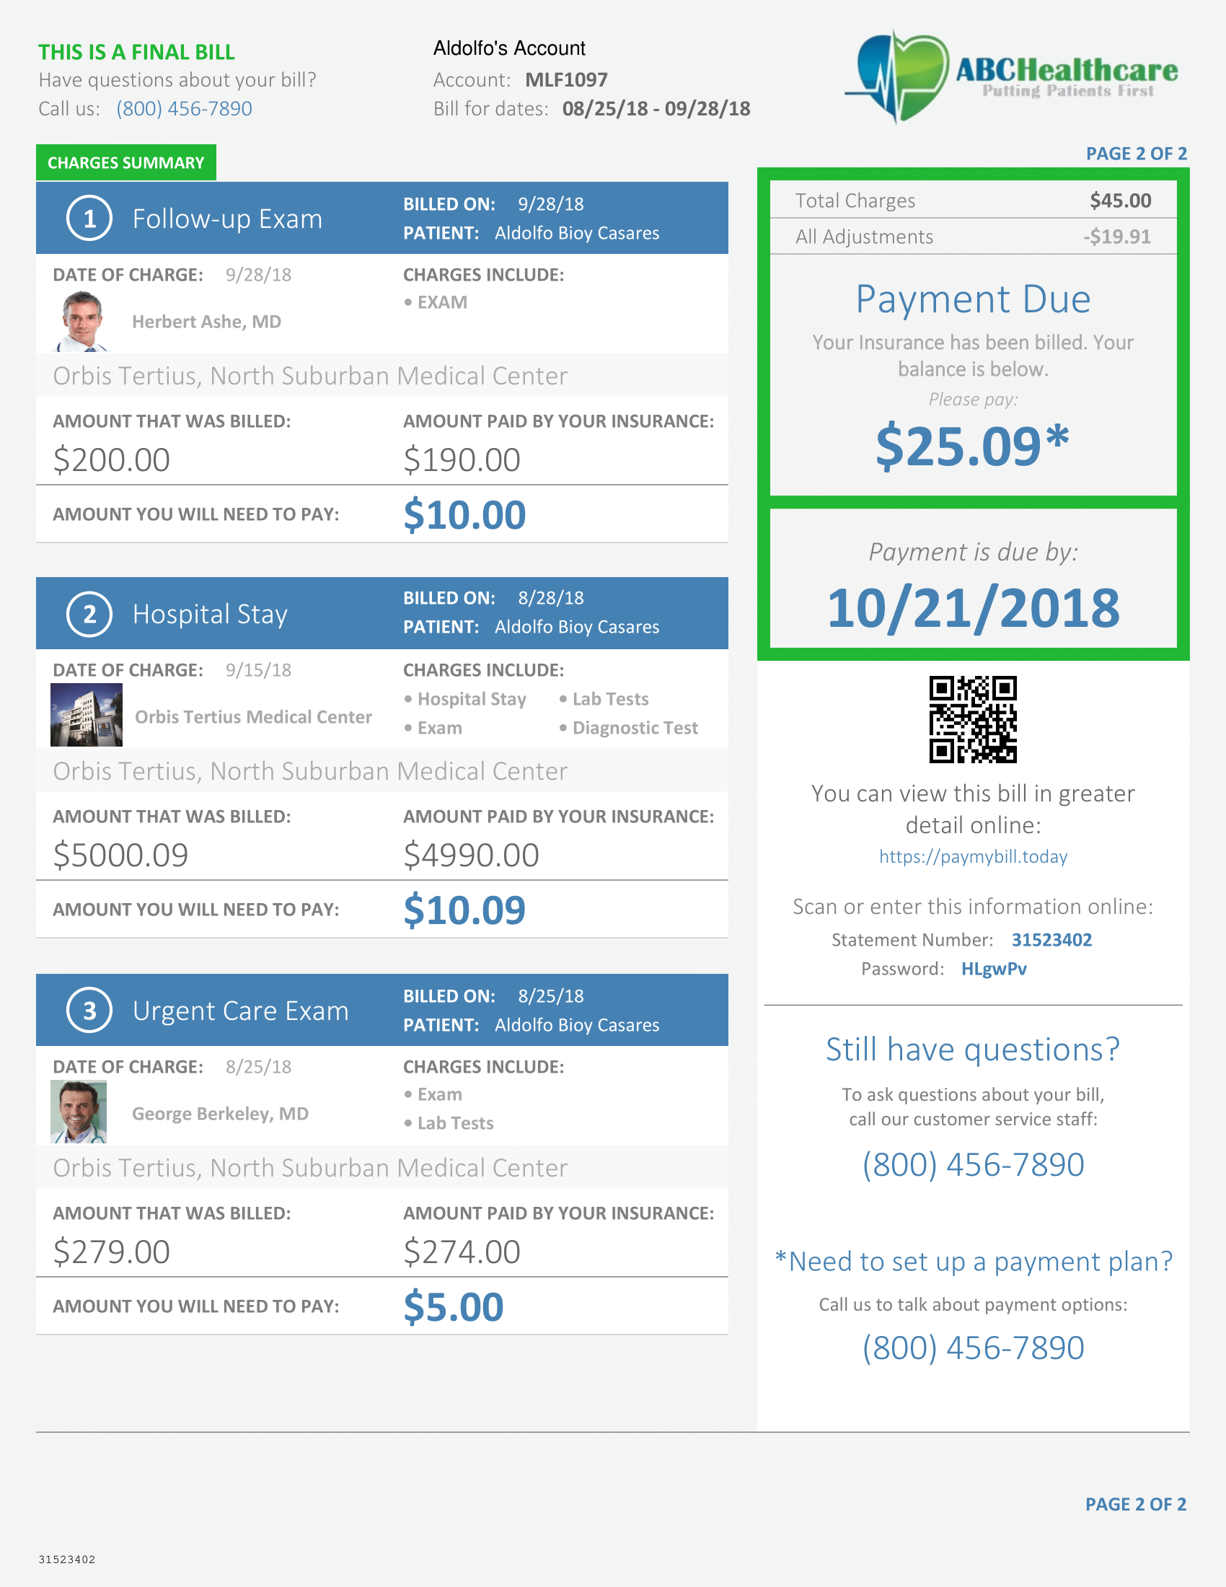

**Contractual Adjustment**

**A Contractual Adjustment is a part of a patient's bill that a doctor or hospital must write-off (not charge for) because of billing agreements with the insurance company.**

Contractual adjustment in the US healthcare system refers to a financial adjustment made to a healthcare provider's reimbursement for a covered service under a healthcare contract. This adjustment occurs when the actual payment for a service is different from the contracted rate due to various reasons such as changes in law, regulatory requirements, or coding and billing errors.

**For example**, if a healthcare provider and an insurance company have a contract that specifies a reimbursement rate of $100 for a certain service, but later it is discovered that the service was coded incorrectly, the insurance company may adjust the payment to the correct amount, which may be lower or higher than the contracted rate. The difference between the contracted rate and the actual payment is known as a contractual adjustment.

This adjustment process is a common practice in the US healthcare system and helps to ensure that healthcare providers are fairly reimbursed for the services they provide and that insurance companies are paying the correct amount for those services.

**Not Everything will have a Contractual Adjustment**

An important thing to remember about Contractual Adjustment’s is that they are only made on services covered by the insurance company.  This means that a patient who requires a certain medical service which the insurance company does not cover will end up paying the full amount charged by the medical provider with no contractual adjustment to limit the cost.

An **example** of a Contractual Adjustment is when a provider charges a practice fee for a certain service of $100.  The contracted rate between the insurance company and the provider for this service is $80, with the insurer paying $64, or 80%, and the remaining 20% of the contracted rate amount paid by the patient.  The $20 difference between the $100 charged by the provider and the $80 collected is adjusted off the patient account as a contractual adjustment.

**Group Codes for the claim Adjustment**

Use the below category codes, when a joint payer/payee agreement or a regulatory requirement has resulted in an adjustment that the member is not responsible for, or when the provider’s charge exceeds the reasonable and customary amount for which the patient is responsible.

* **CO-Contractual Obligations:** This group code should be used when a joint contractual agreement between the payer and payee, or a regulatory requirement, resulted in an adjustment. Generally, these adjustments are considered a write off for the provider and are not billed to the patient.
* **OA-Other Adjustments:** This group code should be used when no other group code applies to the adjustment.
* **PI-Payer Initiated Reductions:** This group code should be used when, in the opinion of the payer, the adjustment is not the responsibility of the patient, but there is no supporting contract between the provider and the payer.
* **PR-Patient Responsibility:** This group should be used when the adjustment represents an amount that should be billed to the patient or insured. This group code would typically be used for deductible and copay adjustments.

**Q. Are write-off and contractual**

**adjustments the same?**

A contractual adjustment is the amount that the carrier agrees to accept as a participating provider with the insurance carrier. A write off is the amount that cannot be collected from patient due to several issues. Documentation is required for any patient balance adjustment for auditing purposes.

**Q. Difference between CO, OA, PI and PR in US Health care Industry?**

In the context of US health care, CO, OA, PI, and PR are acronyms used to describe different types of contractual adjustments between healthcare providers and payers (such as insurance companies).

* **CO refers to a "Contractual Obligation**," which means that a healthcare provider is required to accept the reimbursement rate set by the payer, regardless of the actual cost of the service provided. For example, if a hospital has a CO with a payer for a specific procedure, the hospital must accept the predetermined rate set by the payer for that procedure, even if the hospital's actual cost for that procedure is higher.
* **Other Allowances (OA):** This type of adjustment is made for reasons that are not covered by a Contracted Adjustment (CO), such as billing errors or duplicate claims. OA adjustments can be made by either the provider or the payer and they may result in a reduction or increase in the reimbursement amount. For example, if a provider accidentally submits a duplicate claim for a medical service, the payer may initiate an OA adjustment to correct the error and reduce the reimbursement amount.
* **Payer Initiated Reduction (PI):** This type of adjustment is initiated by the payer and is made for a variety of reasons, including the discovery of overpayments, the implementation of new payment policies, or the adjustment of claims for services that were deemed medically unnecessary. PI adjustments typically result in a reduction in the reimbursement amount paid to the provider. For example, if a payer discovers that they overpaid a provider for a medical service, they may initiate a PI adjustment to recoup the overpayment.
* **PR** refers to a "**Patient Responsibility**" adjustment, which is the portion of the cost of a service that the patient is responsible for paying. This could include copays, deductibles, or coinsurance. For example, if a patient has a $30 copay for a doctor's visit, the PR adjustment would be $30

Example:

A patient visits a healthcare provider for a medical service that has an allowed amount of $100. The provider's cost for the service is $110, and the patient is responsible for a $20 copayment. In this scenario, the payer might make the following adjustments to the claim:

* CO adjustment: $10 (to account for the difference between the provider's cost and the allowed amount)
* PR adjustment: $20 (to account for the patient's copayment)

The total reimbursement amount paid to the provider would then be $70 ($100 allowed amount - $10 CO adjustment - $20 PR adjustment).

In summary, CO, OA, PI, and PR are all different types of contractual adjustments used in the US health care system to determine the reimbursement rate for healthcare services and the responsibilities of healthcare providers and patients.

**Q. What is PR.01 and PR.02 in case of contractual adjustment?**

PR.01 and PR.02 are codes used in the context of contractual adjustments in the US healthcare system to indicate the patient's responsibility for paying a portion of the cost of a healthcare service or product. These codes are typically used in conjunction with claim submissions to indicate the amount that the patient is responsible for paying.

**PR.01** is a code that indicates deductible amount. A deductible amount is the amount of money which the insured part must pay before the insurance company’s own coverage plan begins. In practical terms, insurance companies include a deductible in their policies to avoid paying out benefits on relatively small claims.

**PR.02** is a code that indicates the patient is responsible for a coinsurance, which is a percentage of the cost of a healthcare service that the patient must pay, after the deductible has been met. This code is used to indicate that the patient is responsible for paying a portion of the cost of the service, as determined by their insurance plan.

**PR.03** is a code that indicates that the patient is responsible for Co-payment used in the adjustment process. Which is a flat fee that the patient must pay before receiving and treatment

It is important to note that these codes are only one part of the information used in the adjustment process, and they are typically used in conjunction with other codes and information to determine the total reimbursement amount paid to the provider. The specific codes and information used will depend on the terms of the patient's insurance plan and the type of service that was provided.

**Cross Over Claim**

A crossover claim in the US healthcare system refers to a claim that is initially processed by one insurance provider but then shifted to another insurance provider for payment. This occurs when the primary insurance provider determines that the claim should have been paid by a secondary insurance provider.

**For example**, a patient has both a primary insurance provider and a secondary insurance provider. The patient visits the doctor and incurs medical expenses. The primary insurance provider processes the claim and determines that the medical expenses should be covered by the secondary insurance provider. The primary insurance provider sends the claim to the secondary insurance provider for payment, which is known as a crossover claim.

The crossover claim process is designed to streamline the payment process and ensure that the patient receives the appropriate insurance coverage for their medical expenses. The crossover claim process can also help reduce the administrative burden on healthcare providers, who are often responsible for submitting claims to multiple insurance providers.

In conclusion, a crossover claim in the US healthcare system refers to a claim that is processed by one insurance provider but shifted to another insurance provider for payment. This process helps ensure that patients receive the appropriate insurance coverage and helps reduce the administrative burden on healthcare providers.

**Q. Why there is a need of Cross Over claim in US Health care??**

The need for cross-over claims in US medical history arose because of the growing complexity and cost of healthcare. Cross-over claims refer to when a patient's healthcare benefits from one payer (e.g. insurance company) "crossover" to another payer, typically a government program such as Medicare, to help pay for remaining medical expenses not covered by the primary insurance. This process was implemented to help ensure that patients receive necessary medical care, especially for those with chronic or long-term health conditions, without being burdened by excessively high out-of-pocket costs.

**Date of Service (DOS)**

The date of service in the US healthcare system refers to the date when a medical service was provided to a patient. It is an important part of the billing process for medical insurance claims, as it helps determine the patient's insurance coverage and the payment responsibility of the insurance company and the patient.

**For example**, let's say a patient visits a doctor on March 15, 2020, for a routine check-up. The doctor performs several tests and diagnoses the patient with a minor illness. The doctor provides the patient with a prescription for medication and schedules a follow-up visit in two weeks.

The date of service for this visit would be March 15, 2020. The insurance company would use this date to determine the patient's insurance coverage and the payment responsibility for the medical services provided on that day. The insurance company would then process the medical claim for the services rendered on March 15, 2020, based on the date of service.

In conclusion, the date of service is a critical component in the US healthcare system, as it helps determine the insurance coverage, payment responsibility, and the processing of medical insurance claims.

**Day Sheet**

A day sheet in the US healthcare system is a document used by healthcare facilities to track patient activity and transactions throughout the day. It serves as a record of all patient-related activities such as admission, discharge, diagnostic procedures, treatments, medications, and charges.

**For example**, in a hospital setting, the day sheet would include the patient’s name, admission date, diagnosis, and treatment plan. The sheet would also list any procedures performed, medications administered, and the cost of each item. The day sheet is typically updated on a daily basis, allowing the facility to track patient progress and keep an accurate record of all transactions.

At the end of each day, the day sheet is used to summarize all patient activity, including financial transactions, and provide a report of the facility’s daily operations. This information is critical in managing patient care, tracking patient progress, and ensuring that all billing and payment processes are accurate and timely.

In summary, the day sheet is a valuable tool in the US healthcare system that helps healthcare facilities to manage patient care, track patient progress, and ensure accuracy in billing and payment processes.Top of Form

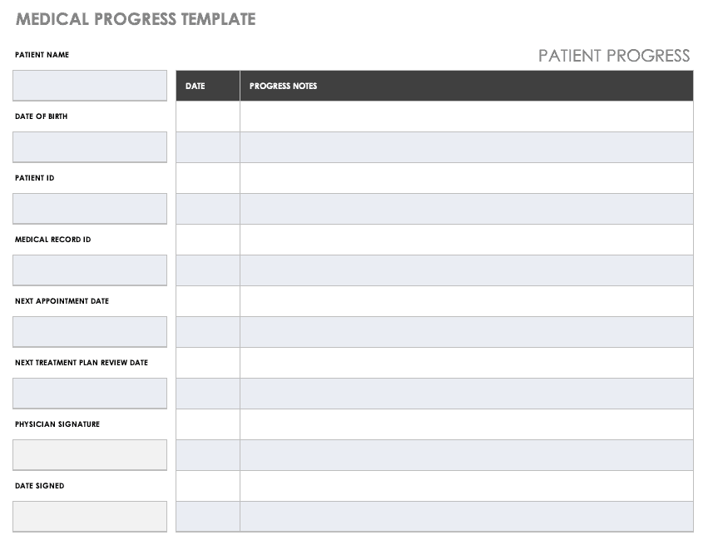

**Fee Schedule**

A fee schedule in the US healthcare system refers to a list of standardized payment amounts for specific medical procedures, services, and treatments. This fee schedule is used by insurance companies, Medicare, and Medicaid to determine the amount of reimbursement that healthcare providers can receive for their services.

**For example**, let's say a patient goes to their doctor for a routine check-up. The doctor performs a physical examination, takes blood pressure readings, and checks the patient's weight. According to the fee schedule, the doctor can receive a payment of $100 for this type of examination. The insurance company will review the fee schedule to determine the payment amount and then send the payment to the doctor. General medical procedure like vaccinations are part of the Fee Schedule but on the other hand surgeries or complex diagnostic procedures like MRI or CT scan are not part of the fee schedule. These procedures are typically billed separately and may not have a set fee and can vary according to the insurance’s plan.

The fee schedule helps to ensure that healthcare providers are reimbursed fairly and consistently for the services they provide. It also helps to control healthcare costs by limiting the amount of money that insurance companies are required to pay for each procedure.

However, there are limitations to the fee schedule in the US healthcare system. Some healthcare providers may believe that the payment amounts are too low to cover the cost of their services, and may choose not to participate in insurance plans that use a fee schedule. Additionally, the fee schedule may not always reflect the actual cost of a procedure, which can result in healthcare providers incurring losses for some services.



**CMS**

CMS stands for the Centers for Medicare and Medicaid Services, which is an agency within the U.S. Department of Health and Human Services. It is responsible for administering two of the largest federal health care programs: Medicare and Medicaid.

Medicare is a federal health insurance program for people who are 65 or older, people with certain disabilities, and people with end-stage renal disease (permanent kidney failure requiring dialysis or a transplant). Medicaid is a joint federal and state program that provides health coverage for people with low incomes, including families, children, pregnant women, and people with disabilities.

An example of CMS in the U.S. healthcare system can be seen through its role in the administration of Medicare. For example, CMS sets payment policies for hospitals and other health care providers that participate in Medicare, such as how much they will be paid for the services they provide to Medicare beneficiaries. CMS also sets quality standards for the care that Medicare beneficiaries receive, and it oversees the quality of care provided by hospitals, nursing homes, and other health care providers. Additionally, CMS operates the Medicare.gov website, which provides information and resources to help Medicare beneficiaries understand their health care options and make informed decisions.

Overall, CMS plays a critical role in the U.S. healthcare system by administering important federal health programs and ensuring that they are run effectively and efficiently to serve the needs of the American people.

**Collection Ratio**

Collection ratio in the US healthcare system refers to the percentage of the total amount charged to patients or insurance companies that is actually collected by healthcare providers. This ratio is an indicator of the financial performance of healthcare organizations, as it shows how effective they are at collecting payments for services rendered.

**For example**, if a healthcare provider charges $100,000 in total for services and collects $90,000, their collection ratio would be 90%. In other words, 90% of the amount charged was collected, while 10% remained outstanding.

This ratio is important to track because it indicates the financial health of a healthcare organization. If the collection ratio is low, it may mean that patients are not paying their bills, insurance companies are denying claims, or there is a problem with the billing process. In such a scenario, the healthcare organization may have to write off uncollected amounts as bad debt, which can have a significant impact on their bottom line.

A high collection ratio, on the other hand, is a sign of good financial management, as it indicates that the organization is effectively collecting payments from patients and insurance companies. This, in turn, enables the healthcare organization to provide quality care, invest in new technology and equipment, and maintain a healthy financial position.

In conclusion, the collection ratio is a crucial metric for healthcare organizations in the US, as it provides insight into their financial performance and helps them make informed decisions about their business operations

**Net Collection Ratio = Payments / (Account Receivable + Payments + Bad Debt Adjustments)**.

**Group Name in Medical Billing for Insurance**

In medical billing, the "group name" refers to the name of the group of individuals that is covered under a single insurance policy. This group could be a family, a group of employees, or any other type of organization or association.

For example, a group name could be "Smith Family Health Insurance" if it covers a family of four individuals named Smith. Another example could be "ABC Corporation Employee Benefits" if it covers all employees of the ABC Corporation.

The group name is important in medical billing because it is used to identify the specific insurance policy and the individuals who are covered under that policy. This information is used to process insurance claims, determine the insurance benefits available, and ensure that the correct individual is being billed for the services received.

**Group Number**

The group number in medical billing is a unique identifier assigned by the insurance company to each policyholder or group of policyholders who are enrolled in a group insurance plan. It is used to distinguish between different insurance policies and to track the policyholder’s coverage and claims.

For example, if a large corporation enrolls all of its employees in a group health insurance plan, each employee would receive an individual policy with the same group number. This would allow the insurance company to easily track the coverage and claims of each employee, and to process payments and reimbursements efficiently.

In another example, if a family enrolls in a family insurance plan, each member of the family would receive an individual policy with the same group number. This would allow the insurance company to easily track the coverage and claims of each member, and to process payments and reimbursements efficiently.

The group number is usually included on the insurance card along with the policyholder’s name, identification number, and other relevant information. It is important for the policyholder to have their group number readily available when visiting a healthcare provider, as the provider will typically use the group number to verify the policyholder’s insurance coverage and eligibility for certain services.

In summary, the group number in medical billing is a unique identifier used by insurance companies to track the coverage and claims of policyholders enrolled in group insurance plans.

**Q. What’s the difference between Group Name and Group Number?**

In the US healthcare system, the group name and group number are two distinct pieces of information used to identify a group insurance plan.

The group name refers to the name of the organization or employer that has purchased the insurance policy for its employees or members. For example, if a company called "ABC Inc." purchases a group insurance plan for its employees, the group name would be "ABC Inc."

The group number, on the other hand, is a unique identifier assigned by the insurance company to the specific policy purchased by the group. This number is used to track the coverage and claims of the policyholder and to distinguish between different policies. For example, if "ABC Inc." purchases a group insurance policy with an insurance company, the insurance company would assign a unique group number to that policy, such as "12345."

In conclusion, the group name identifies the organization or employer that has purchased the insurance policy, while the group number is a unique identifier assigned by the insurance company to the specific policy purchased by the group.

Top of Form

**In-Patient**

Inpatient refers to a patient who is admitted to a hospital or healthcare facility and stays overnight for medical treatment or observation. An inpatient receives medical care and services 24 hours a day, usually in a hospital setting. The patient is assigned a bed in a room or ward and is cared for by a team of healthcare providers, including doctors, nurses, and support staff.

For example, if someone is experiencing chest pain and requires a heart catheterization (CPT-93458), they would typically be admitted to the hospital as an inpatient. They would stay overnight in a hospital room and receive round-the-clock care from a healthcare team until it is determined that they are well enough to go home.

**Out-Patient**

Outpatient care refers to medical services that are provided to patients who do not require overnight stay in a hospital or medical facility. It typically involves medical procedures or treatments that can be performed on an outpatient basis, without the need for an overnight stay.

Examples of outpatient care include:

* Doctor’s office visit: This can include a routine check-up, physical examination, or diagnostic testing.
* Diagnostic imaging: Patients may need X-rays, MRI scans, CT scans, or ultrasound scans performed on an outpatient basis.
* Laboratory testing: Patients may need blood tests, urine tests, or other diagnostic tests performed at a laboratory.
* Minor surgical procedures: Outpatient surgery can include procedures such as biopsies, removal of skin growths, or the repair of minor injuries.
* Physical therapy: Patients who have had surgery or are recovering from an injury may receive physical therapy on an outpatient basis.
* Chemical dependency treatment: Patients may receive counseling, support groups, and other treatments for substance abuse or addiction.

The advantage of outpatient care is that patients can receive medical treatment without being hospitalized, which is typically less expensive and more convenient. In addition, patients can often return home the same day, allowing them to recover in their own environment.

**Medicare and its Types**

Medicare is a federally funded health insurance program that provides coverage to eligible individuals who are aged 65 or older, individuals with certain disabilities, and individuals with End-Stage Renal Disease (ESRD). It is administered by the Centers for Medicare and Medicaid Services (CMS).

There are four types of Medicare:

* **Medicare Part A (Hospital Insurance):** This type of Medicare covers inpatient hospital stays, skilled nursing facilities, hospice care, and some home health care services. For example, if a patient requires hospitalization for a serious illness or injury, Medicare Part A will pay for their stay in the hospital.
* **Medicare Part B (Medical Insurance):** This type of Medicare covers outpatient medical services such as doctor visits, diagnostic tests, medical equipment, and preventive services. For example, if a patient needs a laboratory test or X-ray, Medicare Part B will cover the cost of the service.
* **Medicare Part C (Medicare Advantage):** This type of Medicare is a private alternative to traditional Medicare. Medicare Advantage plans provide all of the benefits of Parts A and B, as well as some additional benefits such as prescription drug coverage. For example, if a patient enrolls in a Medicare Advantage plan, they will receive all of their medical care through the private plan and may have lower out-of-pocket costs. Medicare Advantage Plans are Medicare-approved private health plans.
* **Medicare Part D (Prescription Drug Coverage):** This type of Medicare provides coverage for prescription drugs. It is available as a stand-alone plan or as part of a Medicare Advantage plan. For example, if a patient requires prescription drugs for a chronic condition, they can enroll in a Medicare Part D plan to help pay for the cost of their medications.

In summary, Medicare is a comprehensive health insurance program that provides coverage for a wide range of medical services to eligible individuals.

**Medicaid Plan**

Medicaid is a jointly funded, federal-state health insurance program that provides coverage to individuals with low incomes and limited resources. It is administered by the Centers for Medicare and Medicaid Services (CMS) and is designed to help ensure that low-income individuals have access to necessary medical care.

Eligibility for Medicaid is determined by income and resources, as well as by specific categories, such as pregnant women, children, elderly individuals, and individuals with disabilities. In most states, eligibility is based on the federal poverty level (FPL), which is updated annually.

Examples of scenarios where individuals may be eligible for Medicaid include:

* **Pregnant women:** A pregnant woman who earns less than the FPL may be eligible for Medicaid coverage. This can include coverage for prenatal care, delivery, and postpartum care.
* **Children:** Children who live in low-income households may be eligible for Medicaid. This can include coverage for routine health care, immunizations, and preventive services.
* **Elderly individuals:** Individuals who are aged 65 or older and have low incomes may be eligible for Medicaid. This can include coverage for nursing home care, home health care, and other long-term care services.
* **Individuals with disabilities:** Individuals with disabilities who have limited income and resources may be eligible for Medicaid. This can include coverage for medical equipment, rehabilitation services, and home health care services.
* **Individuals in poverty:** Individuals who are living in poverty and do not have access to other health insurance may be eligible for Medicaid. This can include coverage for medical, dental, and mental health services.

Medicaid is an important source of health coverage for low-income individuals, and it helps ensure that they have access to necessary medical care. By providing comprehensive health coverage, Medicaid helps to reduce health disparities and improve overall health outcomes for individuals in need.

**Network Provider**

A network provider in the US healthcare system refers to a healthcare provider that has contracted with a health insurance company or a Medicare Advantage plan to provide medical services to its enrolled patients. The provider agrees to accept a set rate for their services and the insurance company or Medicare Advantage plan agrees to cover the cost of those services.

Examples of network providers include:

* **Primary care physicians:** These are providers who are typically the first point of contact for patients seeking medical care. They can provide preventive care, diagnose and treat illnesses, and refer patients to specialists as needed.
* **Specialists:** These are providers who have specialized training in a particular area of medicine, such as cardiology, oncology, or gastroenterology. They provide specialized medical care to patients and work in collaboration with primary care physicians.
* **Hospitals:** Hospitals are medical facilities that provide inpatient and outpatient medical services, including emergency care, surgery, and rehabilitation.
* Laboratories: Laboratories provide diagnostic testing services, such as blood tests, X-rays, and CT scans.
* **Pharmacies:** Pharmacies dispense prescription medications to patients and provide information about how to take those medications safely and effectively.
* **Home health agencies:** Home health agencies provide medical care and support services to patients in their homes, including nursing care, physical therapy, and home health aides.

By participating in a network, healthcare providers agree to provide medical services to enrolled patients at a lower cost, and insurance companies or Medicare Advantage plans agree to cover the cost of those services. This helps to control the cost of healthcare and ensures that patients have access to necessary medical services. Patients typically have lower out-of-pocket costs when they use network providers, as opposed to providers who are not in their network.

**Out of Network Provider**

An out-of-network provider in the US healthcare system refers to a healthcare provider who has not contracted with a health insurance company or a Medicare Advantage plan to provide medical services to its enrolled patients. This means that the provider has not agreed to accept a set rate for their services, and the insurance company or Medicare Advantage plan may not cover the full cost of those services.

Examples of out-of-network providers include:

* Specialists: A specialist who has not contracted with a patient's insurance company may be considered out-of-network. This can result in higher costs for the patient, as the insurance company may not cover the full cost of the services provided by the specialist.
* Hospitals: A hospital that is not in a patient's network may charge higher rates for its services, and the insurance company may not cover the full cost of those services.
* Laboratories: A laboratory that is not in a patient's network may charge higher rates for its diagnostic testing services, and the insurance company may not cover the full cost of those services.
* Pharmacies: A pharmacy that is not in a patient's network may charge higher prices for prescription medications, and the insurance company may not cover the full cost of those medications.
* Home health agencies: A home health agency that is not in a patient's network may charge higher rates for its medical care and support services, and the insurance company may not cover the full cost of those services.

Using out-of-network providers can result in higher costs for patients, as the insurance company may not cover the full cost of the services provided by the provider. Patients typically have higher out-of-pocket costs when they use out-of-network providers, as opposed to providers who are in their network. Patients should always check with their insurance company to check that the provider they are going for checkup is Network Provider or Out-Of-Network Provider.

Top of Form

**PCP**

PCP stands for Primary Care Physician in the US healthcare system. A primary care physician is the first point of contact for patients seeking medical care and is responsible for managing their overall health and wellness.

Examples of services provided by a primary care physician include:

* **Preventive care:** Primary care physicians provide preventive care, such as routine physical exams, screenings for conditions like cancer and heart disease, and vaccinations.
* **Diagnosis and treatment of illnesses:** Primary care physicians diagnose and treat common illnesses, such as the flu, colds, and infections. They may also manage chronic conditions, such as diabetes and hypertension.
* **Referrals to specialists:** When necessary, primary care physicians refer patients to specialists for more specialized medical care. For example, a patient with a heart condition may be referred to a cardiologist.
* **Coordination of care:** Primary care physicians are responsible for coordinating the care that a patient receives from multiple providers. They ensure that all of the patient's medical records are up-to-date and that all of the patient's providers have the information they need to provide the best possible care.
* **Patient education:** Primary care physicians educate patients about their health and wellness, helping them to make informed decisions about their care.

Having a primary care physician is important because they are the foundation of a patient's healthcare team. They provide preventive care and help to manage illnesses, and they ensure that patients receive the care they need from the right provider at the right time. Patients typically have a long-term relationship with their primary care physician, and this relationship can be a valuable source of support and guidance for patients and their families.

**POS**

POS (Point of Service) is a type of insurance plan in which you pay less if you use doctors, hospitals, and other health care providers that belong to the plan’s network

A POS plan blends features of an HMO with a PPO. With POS plan, you may have:

* More freedom to choose your health care providers than you would in an HMO
* A moderate amount of paperwork if you see out-of-network providers
* A primary care doctor who coordinates your care and who refers you to specialists

**What doctors you can see:** You can see in-network providers your primary care doctor refers you to. You can see out-of-network doctors, but you'll pay more.

**What you pay:**

* **Premium:** This is the cost you pay each month for insurance.
* **Deductible:** Your plan may require you to pay the amount of a deductible before it covers care beyond preventive services. You may pay a higher deductible if you see an out-of-network provider.
* **Copays or coinsurance:** You will pay either a copay, such as $15, when you get care or coinsurance, which is a percent of the charges for care. Copayments and coinsurance are higher when you use an out-of-network doctor.

**Paperwork involved:** If you go out-of-network, you have to pay your medical bill. Then you submit a claim to your POS plan to pay you back.

**KEY TAKEAWAYS**

* Point-of-service (POS) plans usually offer lower costs, but their list of providers may be limited.
* POS plans are similar to health maintenance organization (HMO), but POS plans allow customers to see out-of-network providers.
* A POS policyholder is responsible for filling all the paperwork when they visit an out-of-provider,

**How a POS Works?**

A POS plan is similar to an HMO. It requires the policyholder to choose an in-network primary care doctor and obtain referrals from that doctor if they want the policy to cover a specialist’s services. And a POS plan is like a PPO in that it still provides coverage for out-of-network services, but the policyholder will have to pay more than if they used in-network services.

However, the POS plan will pay more toward an out-of-network service if the primary care physician makes a referral than if the policyholder goes outside the network without a referral. The premiums for a POS plan fall between the lower premiums offered by an HMO and the higher premiums of a PPO.

POS plans require the policyholder to make co-payments, but in-network co-payments are often just $10 to $25 per appointment. POS plans also do not have deductibles for in-network services, which is a significant advantage over PPOs.

POS plans offer nationwide coverage, which benefits patients who travel frequently. A disadvantage is that out-of-network deductibles tend to be high for POS plans. When a deductible is high, it means that patients who use out-of-network services will pay the full cost of care until they reach the plan’s deductible. A patient who never uses a POS plan’s out-of-network services probably would be better off with an HMO because of its lower premiums.

**Disadvantage of POS Plans**

Though POS plans combine the best features of HMOs and PPOs, they hold a relatively small market share. One reason may be that POS plans are marketed less aggressively than other plans. Pricing also might be an issue. Though POS plans can be up to 50% cheaper than PPO plans, premiums can cost as much as 50% more than for HMO premiums.

While POS plans are cheaper than PPO plans, plan details can be challenging, the policies can be confusing, and many consumers don’t understand how the associated costs work. Read the plan documents especially carefully—and compare them to other choices—before deciding whether this is the best option.

**DME**

DME stands for Durable Medical Equipment in the US healthcare system. Durable medical equipment refers to medical devices that are designed to withstand repeated use and are used to help individuals with a variety of medical conditions.

Examples of durable medical equipment include:

* **Wheelchairs:** Durable wheelchairs are used by individuals with mobility impairments to help them get around.
* **Oxygen equipment:** Oxygen equipment, such as oxygen tanks and concentrators, are used by individuals with respiratory conditions to help them breathe.
* **Hospital beds:** Hospital beds are used by individuals who are recovering from an illness or injury and need to stay in bed for an extended period of time.
* **Walkers:** Walkers are used by individuals with mobility impairments to help them get around.
* **Prosthetic devices:** Prosthetic devices, such as artificial limbs, are used by individuals who have lost a limb to help them walk and perform other activities of daily living.
* **Patient lifts:** Patient lifts are used by individuals with mobility impairments to help them get in and out of bed, or to help them transfer from a wheelchair to a bed or vice versa.

Durable medical equipment is typically covered by Medicare, Medicaid, and most private health insurance plans. However, coverage can vary depending on the type of equipment and the individual's insurance plan. Patients should check with their insurance company to determine what their coverage is for durable medical equipment before they purchase or rent any equipment. In some cases, patients may be required to obtain a prescription from their physician before they can receive coverage for durable medical equipment.

**Referral**

Referral in the US healthcare system refers to the process of referring a patient from one healthcare provider to another healthcare provider for further evaluation, treatment, or medical care. A referral may be required when a patient requires medical care beyond the scope of practice of the original healthcare provider, or when a patient requires specialized care that the original healthcare provider is unable to provide.

For example, a patient with a suspected heart condition may be referred by their primary care physician to a cardiologist for further evaluation and treatment. The cardiologist will then diagnose and treat the patient and provide feedback to the primary care physician about the patient's progress.

Electronic Data Interchange (EDI) is the electronic exchange of business documents between two or more organizations. In the context of healthcare, EDI refers to the electronic exchange of healthcare data between healthcare providers, insurance companies, and other stakeholders in the healthcare system. In the case of referrals, EDI enables healthcare providers to exchange referral information electronically, which streamlines the referral process and helps ensure that the patient receives the care they need in a timely and efficient manner.

The most common EDI used in the US healthcare system for referrals is the Health Insurance Portability and Accountability Act (HIPAA) EDI standard. This standard defines the data elements, data structure, and transaction sets needed to support electronic transactions in healthcare, including referrals. The use of HIPAA EDI enables healthcare providers to exchange referral information securely and accurately, which helps to ensure that the patient receives the right care at the right time.

**Pre-Authorization**

Pre-Authorization also called precertification refers to a requirement by health plans for patients to obtain approval of a health care service or medication before the care is provided. This allows the plan to evaluate whether care is medically necessary and otherwise covered.

You can also say it like that the pre-authorization is a restriction placed in certain medications, tests, or health services by your insurance company that requires your doctor to first check and be granted permission before your plan will cover the item.

For example, imagine that you have a plan with a health insurance company and need a CT scan for a medical condition. Before the CT scan can be performed, the insurance company will need to review and approve the request for the scan. This process is known as pre-authorization. The insurance company will typically ask your healthcare provider for information about your medical condition, the reason for the scan, and the medical necessity of the procedure.

Once the insurance company has reviewed this information, they will decide on whether the CT scan will be covered under your insurance plan. If the scan is approved, the insurance company will typically provide a pre-authorization number that the healthcare provider will need to use when billing for the procedure. If the scan is not approved, the insurance company will explain why the procedure is not covered, and you may need to discuss alternative options with your healthcare provider.

It's important to note that pre-authorization is different from pre-certification, which is a similar process in which an insurance company verifies that a medical service is covered under an individual's insurance plan before the service is provided.

In conclusion, pre-authorization is a key part of the US health care system that helps to ensure that medical services and procedures are covered under an individual's insurance plan and are medically necessary.

**Q. Why is it called Pre-Authorization?**

Patients may even wait days, week or months for a necessary test or medical procedure to be scheduled because physicians need to first obtain similar authorization from an insurer. This tactic, used by insurance company to control costs, is called Pre-Authorization or Prior Authorization.

**Q. What’s the difference between Pre-Authorization and Referral Authorization?**

* **Pre-Authorization:** A system where a provider must receive approval from a staff member of the health plan, such as the health plan medical director, before a member can receive certain health care services.
* **Referral Authorization:** A formal process that authorizes an HMO member to get care from a specialist or hospital. Most HMOs require patient to get a referral from their Primary Care Doctor before seeing a specialist.

**Revenue Code**

Revenue codes are codes used in the US healthcare system to identify and classify different types of services provided to patients in a hospital setting. They are used to categorize the services provided and are essential in the billing process. The use of revenue codes is regulated by the Centers for Medicare and Medicaid Services (CMS), which is a federal agency responsible for the administration of the Medicare and Medicaid programs.

Revenue codes are used to categorize various services such as room and board charges, nursing services, diagnostic procedures, and therapeutic procedures, among others. The codes are used by healthcare providers to bill insurance companies, Medicare, and Medicaid for the services provided to patients.

For example, revenue code 024x is used to describe services related to inpatient hospital stays. These services can include room and board, nursing services, diagnostic procedures, and therapeutic procedures. Revenue code 039x is used to describe services related to rehabilitation services, such as physical therapy or occupational therapy. Revenue code 096x is used to describe services related to laboratory services, such as blood tests or urine tests.

In conclusion, revenue codes play a crucial role in the US healthcare system by allowing healthcare providers to classify and bill for the services they provide to patients. The use of these codes is regulated by CMS and is essential in the billing process to ensure that patients receive the appropriate care and that healthcare providers are fairly compensated for their services.

**RVU**

RVU, or Relative Value Unit, is a system used to determine the value of a medical service or procedure in the US healthcare system. It's a measure of the resources required to provide a specific service, including the time, skill, and equipment involved. RVUs are used by Medicare and private insurance companies to determine how much to pay healthcare providers for their services.

RVUs are calculated based on three components: the physician work involved in performing the service, the cost of the equipment and supplies used, and the overhead expenses associated with the service. The RVUs for each service are then assigned a dollar value, which is used to determine the reimbursement the provider will receive from the insurance company or Medicare.

For example, consider a service such as an office visit. The RVU for an office visit would consider the time the physician spends with the patient, the cost of any equipment used (such as a stethoscope), and the overhead expenses associated with running an office (such as rent, utilities, and administrative staff). The RVU for this service might be 2.0, meaning it takes twice as much resources as a basic service with an RVU of 1.0. Based on the RVU, the insurance company or Medicare would determine a dollar amount to reimburse the provider for the office visit.

It's important to note that RVUs are just one factor used to determine reimbursement. Other factors, such as geographical location, can also impact the payment amount. Nevertheless, RVUs play a significant role in the US healthcare system, as they provide a standardized way of determining the value of a medical service and help ensure that providers are reimbursed fairly for the resources they use to provide care.

**Self-Pay**

Self-pay refers to a situation in which an individual pay for their own healthcare expenses without the assistance of insurance. In the United States, there are many instances where individuals opt for self-pay, including:

* **Uninsured individuals:** Some individuals may choose not to have health insurance or may not be eligible for it. In such cases, they would have to pay for their medical expenses out of their own pocket.
* **Elective procedures:** Some procedures, such as cosmetic surgeries, are often not covered by insurance. In such cases, individuals would have to pay for the procedure themselves.
* **High deductibles or copays:** In some instances, individuals may have insurance plans with high deductibles or copays. In these cases, they may choose to pay for certain procedures themselves in order to avoid paying high out-of-pocket costs.
* **Concierge medicine:** Some individuals may choose to pay a flat fee to a doctor or clinic in order to receive a higher level of personalized care.

Examples of real-life situations where individuals may opt for self-pay in the US include:

* An individual may choose to pay for a cosmetic procedure, such as liposuction, themselves instead of going through insurance.
* A person who has high deductible insurance may choose to pay for a routine physical exam out of pocket, rather than pay the high deductible required by their insurance.
* An uninsured individual may choose to pay for a necessary medical procedure, such as an appendectomy, out of their own pocket.

It's worth noting that self-pay can be a cost-effective option for some individuals, as it often results in lower prices for medical services. However, it can also be financially challenging, as medical expenses can quickly become unaffordable without insurance coverage.

**Primary Insurance**

Primary insurance in the United States health care system refers to the first insurance policy that an individual use to pay for their medical expenses. The primary insurance policy is the insurance policy that pays claims first and is responsible for paying the majority of the medical bills.

For example, consider a person who has both a private insurance policy and Medicare coverage. In this case, the private insurance policy would be considered the primary insurance and Medicare would be considered the secondary insurance. The private insurance policy would pay for the majority of the medical expenses and Medicare would pay for any remaining expenses not covered by the primary insurance policy.

It's important to note that not all individuals have multiple insurance policies. Some individuals may only have one insurance policy, in which case that policy would be considered the primary insurance.

Having a primary insurance policy is important because it helps to ensure that medical expenses are covered. Without a primary insurance policy, an individual would have to pay all of their medical expenses out of their own pocket, which can quickly become unaffordable.

Additionally, having a primary insurance policy helps to ensure that medical providers receive payment for the services they provide. Without a primary insurance policy, medical providers may be less likely to provide medical services or may require payment upfront.

**Secondary Insurance**

Secondary insurance in the United States healthcare system refers to a second insurance policy that an individual has in addition to their primary insurance policy. The secondary insurance policy is designed to provide additional coverage and help to pay for expenses that the primary insurance policy may not cover.

Secondary health insurance is coverage you can buy separately from a medical plan. It helps cover you pay for care and services that your primary medical plan may not. This secondary insurance could be a vision plan, dental plan, or an accidental injury plan. Typically, secondary insurance is billed when your primary insurance plan is exhausted and may help cover additional health care costs.

For example, consider an individual who has both a private insurance policy and Medicare coverage. In this case, the private insurance policy would be considered the primary insurance and Medicare would be considered the secondary insurance. If the private insurance policy does not cover a particular medical expense, the secondary insurance policy (Medicare) would step in and cover the remaining expenses.

It's important to note that not all individuals have secondary insurance. Some individuals may only have one insurance policy, in which case that policy would be considered the primary and only insurance.

Having secondary insurance can provide peace of mind to individuals by ensuring that medical expenses are covered to the greatest extent possible. Additionally, secondary insurance can help to lower out-of-pocket costs and reduce financial burden.

Examples of secondary insurance include:

* Medicare as a secondary insurance to a private insurance policy for individuals who are eligible for both.
* Supplemental insurance, such as gap insurance or critical illness insurance, which provides coverage for specific types of medical expenses not covered by the primary insurance policy.
* An insurance policy provided by an individual's employer in addition to the individual's own insurance policy.

In conclusion, secondary insurance can provide additional financial protection and help individuals to pay for medical expenses not covered by their primary insurance policy.

**Tertiary Insurance**

Tertiary insurance in the United States healthcare system refers to a third insurance policy that an individual has in addition to their primary and secondary insurance policies. Tertiary insurance is designed to provide additional coverage and help to pay for expenses that the primary and secondary insurance policies may not cover.

Tertiary insurance is relatively rare, and most individuals only have one or two insurance policies. However, there are instances where individuals may opt to purchase a tertiary insurance policy to provide additional financial protection.

For example, consider an individual who has a private insurance policy as their primary insurance and Medicare as their secondary insurance. The individual may opt to purchase a supplemental insurance policy to provide additional coverage for expenses not covered by their primary and secondary insurance policies.

Examples of tertiary insurance include:

* Supplemental insurance, such as gap insurance or critical illness insurance, which provides coverage for specific types of medical expenses not covered by the primary or secondary insurance policies.
* Long-term care insurance, which provides coverage for expenses related to long-term care, such as nursing home stays or home health care.

In conclusion, tertiary insurance is a third insurance policy that an individual can have in addition to their primary and secondary insurance policies. Tertiary insurance is designed to provide additional coverage and help to pay for expenses not covered by the primary and secondary insurance policies. However, it is relatively rare, and most individuals only have one or two insurance policies.

**Q. Is Medicare always the primary insurance?**

If the employer has 20 or more employees, then the group health plan pays first and Medicare pays second. If the employer has fewer than 20 employees and isn’t part of a multi-employer or multiple employer group health plan, then Medicare pays first, and the group health plan pays second.  
**Q. Relate Primary, Secondary and Tertiary Insurance?**

Primary, secondary, and tertiary insurance in the United States health care system refers to a hierarchy of insurance policies that an individual has to help pay for medical expenses. Each type of insurance policy serves a different purpose and provides different levels of coverage.

* **Primary insurance** is the first insurance policy that an individual use to pay for their medical expenses. This policy is responsible for paying the majority of the medical bills and is used to cover the costs of routine medical care and hospitalization. Examples of primary insurance include private insurance policies, employer-sponsored insurance policies, and individual health insurance policies.
* **Secondary insurance** is a second insurance policy that an individual has in addition to their primary insurance policy. This policy is designed to provide additional coverage and help to pay for expenses that the primary insurance policy may not cover. Examples of secondary insurance include Medicare and supplemental insurance policies.
* **Tertiary insurance** is a third insurance policy that an individual has in addition to their primary and secondary insurance policies. Tertiary insurance is designed to provide additional coverage and help to pay for expenses not covered by the primary and secondary insurance policies. Examples of tertiary insurance include supplemental insurance policies and long-term care insurance.

In conclusion, primary, secondary, and tertiary insurance are different types of insurance policies that individuals can have to help pay for medical expenses. Each type of insurance policy serves a different purpose and provides different levels of coverage, and individuals may have one, two, or all three types of insurance policies depending on their individual needs and financial situation

**Q. What is the primary goal of tertiary care?**

Tertiary care is another form of specialized care that is a level above secondary case in that it involves supporting patients who are encountering life threatening illnesses and whose vitals are not stabilized.

**Q. What are the benefits of having secondary insurance?**

A secondary insurance policy is a plan that you get on top of your main health insurance. Secondary insurance can help you improve your coverage by giving you access to additional medical providers, such as out-of-network doctors. It can also provide benefits for uncovered health services, such as vision or dental.

**Q. What is REQ and INS response in US Medical Billing?**

"Req" and "Ins" in US medical billing refer to the "Request" and "Insurance" responses.

In the context of medical billing, a Request is a message sent to an insurance company to inquire about a patient's coverage or benefits, such as eligibility, copay, deductible, or prior authorization. The Request may also include a request for payment or reimbursement of a claim. For example, a medical office may send a Request to an insurance company to check if a specific procedure or service is covered by the patient's insurance plan.

The Insurance response refers to the reply that the insurance company sends in response to a Request. The response typically provides information about the patient's coverage and benefits, such as the amount covered, the amount the patient is responsible for, and any requirements for pre-authorization. For example, an insurance company may respond to a Request from a medical office with a message indicating that the procedure in question is covered, but requires a prior authorization.

In conclusion, the Request and Insurance response are an important part of the medical billing process, as they help medical offices determine a patient's coverage and benefits, and facilitate payment and reimbursement for medical services.

**Billing Revenue Cycle**

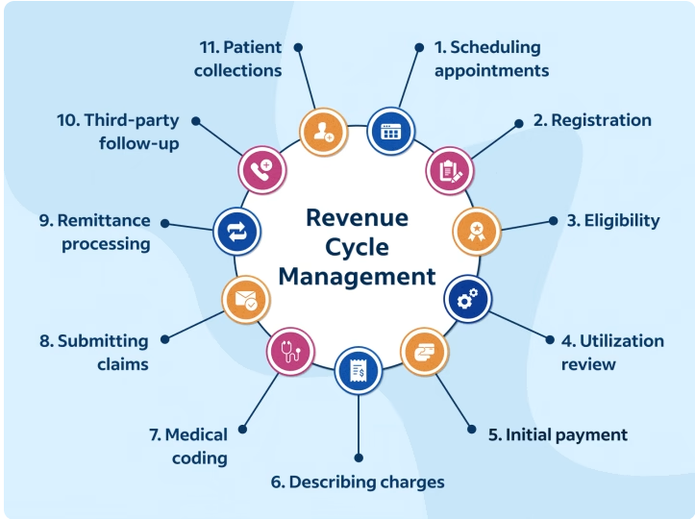

Revenue cycle management (RCM) is a process that details how health care providers charge patients and collect payment for their services. It begins with a patient making an appointment and ends when any outstanding balance is paid. The health care revenue cycle consists of administrative steps involved with the payment process, capturing a patient's experience as they navigate the health care system.

**11 steps of revenue cycle management**

Health care providers may use different systems to manage their revenue cycle, but they usually have the same core steps or elements:

1. **Scheduling Appointments**

The start of the revenue cycle occurs when patients schedule an appointment to access their health care options. When they contact a provider to schedule a checkup, treatment or consultation, the provider indicates their appointment in an RCM system. The cost of the initial appointment is the first indication a provider can expect payment for their time and services. Efficient scheduling is essential for reducing cancellations or no-shows, ensuring that each reserved time slot actually correlates with payment from a patient or insurer.

1. **Registration**

After scheduling, patients go through the pre-registration and registration phase of RCM. This includes collecting all relevant information about the patient, including demographics, medical history and insurance information.

Pre-registration occurs when a patient provides initial information prior to visiting a healthcare provider's office. Registration refers to additional details collected to create a patient account and connect their information with a record number for accurate processing.

1. **Eligibility**

Once registered, providers can check patients’ eligibility for insurance coverage, fee waivers, community programs and other payment assistance. Accuracy is especially important, as an initial eligibility confirmation could later be revoked if the information was incorrect or incomplete.

1. **Utilization review**

A Utilization review is a process in which a patient’s care plan undergoes evaluation, typically for inpatient services on a case-by-case basis. The review determines the medical necessity of procedures and might make recommendations for alternative care or treatment. Utilization reviews serve to evaluate each patient’s care before, during and after procedures to ensure they receive adequate care throughout their hospital stay. Often combined with the eligibility phase, utilization review is the process of determining essential health care services. Insurance companies and medical staff perform a utilization review to confirm a patient is not only eligible for insurance coverage, but they need the procedure or treatment they're requesting. A utilization review uses data-backed clinical guidelines to establish what kind of care is necessary, usually prior to the appointment.

1. **Initial Payment**

Patients sometimes pay up-front for their health care costs to later be reimbursed, or pay a copay at the start of their appointment. The initial payments step involves collecting financial information and processing transactions to limit the chance of missed payments or account delinquency as well as track contributions to prevent overcharging.

1. **Describing charges**

Also known as charge capture, this phase is essential for both the health care provider and patient to have accurate, transparent records about why a visit costs a certain amount. Health care providers use a patient's chart notes to itemize the entire visit, including information on length and type of visit and any procedures performed or medications prescribed.

1. **Medical Coding**

To process an insurance claim after recording charges on a patient's account, health care providers use medical coding to turn a visit summary into an insurance and billing document. Medical coders interpret a patient's file by assigning codes to each type of procedure. These codes exist for insurers to process different types of health care treatment in their systems. Medical coding helps to reverify patient eligibility, prevent denials and generally speed up the process of an insurer reviewing a claim.

1. **Submitting claims**

Next, the health care provider or patient submits their coded information to an insurer, starting a new case file. This administrative process connects the health care provider's documentation with the insurer's information about a patient. Insurance claims must be properly formatted and meet the insurer's requirements to be approved, even if eligibility was pre-confirmed, making accuracy and organization vital. Providers and patients rely on revenue cycle management systems to provide them with updates about when they can expect approval or payment after opening a claim.

The first phase of submission occurs when a claim leaves your practice for review, usually by a clearinghouse service. The clearing house aggregates mountains of electronic claim information, almost all of it managed by software. The clearing house send this information to third-party payers. Once your practice’s claims are ready to be submitted, your system will generate an 837 file, a HIPPA-compliant electronic format used to transmit know your payers healthcare claims and upload them to the clearing house.

**Payer Adjudication Review and Decision**

When a third-party payer receives your claim and starts the review process, its known as adjudication. The payer decides, based on the information you provide, whether the claim is valid and should be paid. Expect payers to review claims meticulously. They want to be assured that you have all the records needed to back them up, especially for high-collar claims. Healthcare payers use a specific file format-the EDI 277 Health Care Claim Status Response transaction set-to report on the status of claims. The 277-file generated by the clearing house indicates whether the payer has accepted you claim and can be automatically loaded into your PM system. If a claim is denied, the 277 files will usually tell you the exact loop and segment where errors or omissions were flagged, as well as the reason for the denial.

1. **Remittance processing**

Remittance is the actual money that an insurer sends to a health care provider once they approve their claim. The insurer sends a remittance statement to the provider explaining how much of a charge they covered and why they covered it. Health care providers save remittance processing information in their systems as a way to reconcile patient accounts and calculate the remainder of their account balance before sending a final invoice.

Remittance refers to the process of getting paid. The Electronic Remittance Advice (ERA) or 835 files, is an electronic transmission of claim payment information. ERA or 835 files can be uploaded directly into your PM system. This file provides an explanation of the claims you’ve submitted—the reasons for payment, adjustment, or denial. Insurers provide two types of statements to explain payment or denial of claims— (1) remittance advice and (2) explanation of benefits (EOB) statements. Usually, the remittance advice is provided to the healthcare provider and the explanation of benefits statement is sent to the patient.

1. **Third-party follow up**

If an insurer doesn't respond to a claim or delays payment, the healthcare provider must follow up with them to collect their payment. When claims are approved but a third-party payer hasn't sent payments, the provider must be able to identify this discrepancy and enforce collections. Third-party follow-up can also involve inquiring about why a claim was denied if a patient was eligible for coverage, fighting the denial and seeking payment.

1. **Patient Collections**

Finally, health care providers charge patient accounts and attempt to collect payment through online portals, mail or phone transactions, or by eventually selling medical debt to a collections agency. This step can involve developing payment plans, seeking out discounts to make payments manageable or charging credit to patients’ accounts while they continue to receive care. Each health care provider has its own policies for collecting payments from patients, updating their accounts to remove charges and sending out payment receipts.

**Q. What are the steps in claim submission which is done from the insurance side in Billing Revenue Cycle?**

In the Billing Revenue Cycle, the following steps are typically involved in claim submission from the insurance side:

* **Receipt of the Claim:** The insurance company receives the claim from the healthcare provider.
* **Claim Validation:** The insurance company checks the claim to ensure that it includes all required information, such as patient and provider details, dates of service, and procedure codes.
* **Adjudication:** The insurance company reviews the claim to determine if the healthcare services provided are covered under the patient's plan. This includes verifying that the patient is eligible for benefits and that the services are medically necessary. If the claim is not covered, the insurance company will deny it.
* **Payment Determination:** If the claim is covered, the insurance company will determine the amount of payment to be made. This may involve applying deductibles, co-payments, or other cost-sharing measures as specified in the patient's plan.
* **Payment Issuance:** Once the payment amount has been determined, the insurance company issues payment to the healthcare provider. This may be in the form of an electronic funds transfer (EFT), a paper check, or other payment method.
* **Explanation of Benefits (EOB):** The insurance company sends an Explanation of Benefits (EOB) to the patient and the healthcare provider. The EOB outlines the amount paid by the insurance company, any patient responsibility amounts, and any remaining balances due.
* **Denial Notification:** If the insurance company denies the claim, they will notify the healthcare provider and patient of the reason for the denial. The healthcare provider may then choose to appeal the decision or take other steps to resolve the issue.

**Q. What are the Five steps of the claim adjudication Process??**

Insurance payers typically use a five-step process to make medical claim adjudication decisions. It is important to know the different steps of the claim adjudication in order to understand how the insurance company determines how claims are paid, rejected or denied.  Medical billing and collection specialists can use these steps to generate, submit and follow-up on claim processing to ensure maximum reimbursement.  The five steps are:

* The initial processing reviews
* The automatic review
* The manual review
* The payment determination
* The payment

**The Initial Processing Review**

In the initial processing review, claims are checked for simple claim errors or omissions.  Problems identified during the initial processing review include:

* The wrong patient name or incorrect spelling
* The subscriber identification number or plan number is wrong
* The place of service code is wrong
* The date of service is wrong
* The diagnosis code is missing or invalid
* The patient's gender does not match the type of service

When a claim is rejected for any of the above reasons, it can simply be corrected and resubmitted for payment.

**The Automatic Review**

In the automatic review, claims are checked for more detailed items that apply to the insurance payer’s payment policies.  Problems identified during the automatic review include:

* The patient is not eligible on the date of service. *This could mean the coverage has termed or is not active.*
* Pre-certification or authorization is not present.  *This could mean that the pre-certification or authorization was not obtained for the service or that the pre-certification or authorization number was not added to the claim prior to submission.*
* Pre-certification or authorization is not valid. *This could mean that the diagnosis, procedure, or date of service does not match the information submitted for the pre-certification or authorization.*
* The claim submitted is a duplicate claim: *This could mean that a claim has already been submitted for the same date or procedure.*
* Timely filing deadline has passed. *Insurance payers typically have a 90 to 120 day time limit for initial claims to be submitted.  If your original claim has not been submitted by the filing deadline, then the claim cannot be processed for payment.*
* The diagnosis or procedure code is invalid.  *The payer will cross check the diagnosis codes and procedure codes listed on the claim to determine whether the codes match.*
* The services performed are not medically necessary.  *This means that the claim does not indicate the patient care was provided at the most appropriate levels and in the most cost-effective manner*

**The Manual Review**

In the manual review, claims are checked by medical claim examiners.  It is not uncommon for nurses or physicians to also manually review these claims during this process.  Medical records may be requested to compare the claim with the medical documentation.  This can be conducted for any type of procedure but most commonly with an unlisted procedure to determine medical necessity.

**The Payment Determination**

There are three types of payment determinations:

* **Paid:** When the claim is considered paid, the payer determines that the claim is reimbursable
* **Denied:** When the claim is considered denied, the payer determines that the claim is not reimbursable
* **Reduced:** When it is determined that the service level billed is too high based on the diagnosis, the procedure code can be down coded to a lower level deemed appropriate by the claim’s examiner

**The Payment**

The payment submitted to the medical office supplied by the insurance payer is called a remittance advice or explanation of payment.  It details the notice of and explanation reasons for payment, reduction of payment, adjustment, denial and/or uncovered charges of a medical claim.

The remittance advice typically includes the following information:

* Payer Paid Amount
* Approved Amount
* Allowed Amount
* Patient Responsibility Amount
* Covered Amount
* Discount Amount
* Adjudication Date

**Q. What is Account Receivables (AR)?**

Accounts receivable (AR) are the balance of money due to a firm for goods or service delivered or used but not yet paid for by customers. Accounts receivable are listed on the balance sheet as a current asset. Any amount of money owed by customers for purchases made on credit is AR.

A medical account receivable refers to the outstanding reimbursement owed to the providers for issued treatments and services, whether the financial responsibility falls to the patient or their insurance company.

The longer an AR goes unpaid, the less likely healthcare providers receive payment at all after 120 days, clinicians can only expect ten cents per dollar owed.

**AR Tracking**

Tracking your accounts receivable every month gives providers the information necessary to identify those at risk of becoming leaked revenue and contributing to bad debt. Providers can compare Ars over time to recognize dangerous trends early and determine any outstanding reimbursements that may prove easy to close.

Providers should analyze their AR data to determine aged debtors and collection rates. These two metrics provide an overview of providers’ AR cycles and whether they are trending in the right direction. Aged debtor reports reveal how many ARs exist within each age group. Collection rates demonstrate how successful providers are at converting ARs to reimbursements in a given accounting period.9

When tracking accounts receivable, providers should run reports to determine their average AR cycles.

Is there a delay between providing care and invoicing? As longer ARs carry a higher risk of becoming forgotten by patients and going unpaid, starting the cycle as quickly as possible can keep them from aging beyond collection. Determining how long the different stages of the AR cycle take can help providers identify where to make improvements.

**Q. What’s the difference between Super bill and Charge in Billing Revenue Cycle in US healthcare?**

In the US healthcare system, a superbill and a charge are both important components of the revenue billing cycle, but they serve different purposes.

A superbill, also known as a **fee ticket** or **encounter form**, is a document that lists the services provided to a patient during a visit to a healthcare provider. It includes the CPT (Current Procedural Terminology) codes and ICD-10 (International Classification of Diseases, 10th Revision) codes that describe the services rendered. The superbill is used to bill insurance companies or other third-party payers for the services provided, and it is often provided to the patient for their own records. The superbill is usually generated by the healthcare provider or their staff, and it is typically specific to the services provided by that provider.

A charge, on the other hand, is the actual amount of money that is billed for a specific service. Charges are typically generated by the billing department of a healthcare organization, and they are based on the codes provided on the superbill. Charges are then used to create a bill or claim that is submitted to the insurance company or other third-party payer. The amount of the charge may be different from the amount that the healthcare provider is reimbursed for the service, as the insurance company or other payer may negotiate a different rate.

In summary, a superbill is a document that lists the services provided to a patient and the codes that describe those services, while a charge is the actual amount of money that is billed for a specific service. The superbill is used to generate the charge, which is then used to create a bill or claim that is submitted to the insurance company or other third-party payer for reimbursement.

**Q. What’s the difference between Electronic Super Bill and Paper Super Bill?**

The key difference between paper and electronic super bills in the US healthcare system is the format in which they are created and delivered. A paper superbill is a physical document that is printed out and provided to the patient or billing department, while an electronic superbill is a digital document that is created and transmitted electronically.

Paper super bills are often used in smaller healthcare practices that may not have the resources to implement electronic billing systems. The paper superbill is typically a pre-printed form that contains fields for the date of service, the CPT and ICD-10 codes, and other relevant information. The healthcare provider or their staff can fill out the form by hand or using a typewriter, and then provide it to the patient or billing department. Examples of paper superbill formats include a CMS-1500 form, a UB-04 form, or a customized form specific to the healthcare practice.

Electronic superbills are created and transmitted using electronic health record (EHR) systems, billing software, or other electronic systems. Electronic superbills can be transmitted directly to the insurance company or other third-party payer, eliminating the need for paper documents. Electronic superbills can be created in various formats, such as HL7 (Health Level Seven) messages or EDI (Electronic Data Interchange) format such as EDI 277 (to authorize from a payer). The format and content of an electronic superbill may vary depending on the EHR or billing system being used.

In summary, paper superbills are physical documents that are filled out by hand or with a typewriter, while electronic superbills are digital documents created and transmitted using electronic systems. Paper superbills are often used in smaller healthcare practices, while electronic superbills are more commonly used in larger healthcare organizations that have implemented electronic billing systems. The format and content of both paper and electronic superbills may vary depending on the specific healthcare practice or electronic system being used.

**Q. Why we use Paper Super Bill rather than Electric Super Bill In medical billing? What’s the need for using paper super bill??**

The use of paper super bills in medical billing is becoming less common as electronic health records and billing systems become more prevalent. However, paper super bills are still used in some medical practices, particularly smaller practices or those that have not fully adopted electronic billing systems.

A paper super bill is a pre-printed form that lists common medical procedures, treatments, and diagnostic tests, along with their corresponding billing codes. The paper super bill is typically completed by the provider or their staff during the patient visit, and is used as a reference for creating a claim or invoice for the patient's services.

One reason that paper super bills may still be used is that they can be customized to the specific needs of a medical practice or provider. Providers can add or remove procedures, treatments, and diagnostic tests based on their specialty or the needs of their patients. Additionally, paper super bills can be easily updated as billing codes change or new procedures are added.

Another reason that paper super bills may still be used is that they can be helpful for providers who are not yet fully comfortable with electronic billing systems or who have limited access to technology. Paper super bills provide a tangible reference that providers can use to ensure that they are accurately billing for their services, without relying on complex electronic systems.

However, there are also some downsides to using paper super bills. They can be time-consuming to complete and may be prone to errors, particularly if the provider or their staff are not well-versed in medical billing and coding. Additionally, paper super bills can be lost or damaged, which can result in delays or errors in billing.

Overall, while paper super bills may still be used in some medical practices, the trend is towards electronic billing and record-keeping. Electronic systems offer increased efficiency and accuracy, as well as greater flexibility and customizability compared to paper systems.

**Q. What is insurance aging? What’s the duration in case of private and Medicare insurance?**

Insurance aging, also known as accounts receivable (AR) aging, is a financial metric used in the healthcare industry to track the amount of time it takes for insurance claims to be paid by insurance companies or other third-party payers. In other words, it measures how long a healthcare organization's outstanding insurance claims have been waiting to be paid.

The duration of insurance aging in the case of private insurance and Medicaid can vary depending on a number of factors, including the specific insurance plan, the state in which the healthcare organization is located, and the policies of the insurance company or Medicaid program. However, in general, private insurance claims tend to have a shorter aging period than Medicaid claims.

Private insurance claims typically have an aging period of 30 to 60 days, meaning that the healthcare organization expects to receive payment within that timeframe. Medicaid claims, on the other hand, may have a longer aging period of 365 days, as the Medicaid program may have a longer processing time.

It's important to note that these aging periods are just general guidelines, and the actual aging period for insurance claims can vary widely depending on the specific circumstances of each claim. Additionally, healthcare organizations may have their own internal policies and procedures for managing and tracking insurance aging, which may be different from these general guidelines.

**Q. Missing Topics in Billing Revenue Cycle?**

**Claim Types**

In the US healthcare industry, there are several types of claims that can be involved in the revenue billing cycle. These claim types can include:

* **Institutional Claims:** These claims are submitted by hospitals, nursing homes, and other healthcare institutions for inpatient and outpatient services, including procedures, treatments, and medications.
* **Professional Claims:** These claims are submitted by healthcare professionals, such as physicians, nurses, and therapists, for services rendered to patients. These claims can include office visits, consultations, and other services provided in a professional setting.
* **Dental Claims:** These claims are submitted by dental providers for services provided to patients, such as cleanings, fillings, and extractions.
* **Pharmacy Claims:** These claims are submitted by pharmacies for medications provided to patients.
* **Vision Claims:** These claims are submitted by vision providers for services such as eye exams, contact lenses, and glasses.
* **Home Health Claims:** These claims are submitted by home healthcare providers for services provided to patients in their homes, including nursing care, physical therapy, and other treatments.
* **Hospice Claims:** These claims are submitted by hospice providers for services provided to terminally ill patients, including nursing care, pain management, and emotional support.
* **Durable Medical Equipment (DME) Claims:** These claims are submitted by providers of medical equipment, such as wheelchairs, oxygen tanks, and other durable medical equipment.

In addition to these types of claims, there is also a type of claim known as a crossover claim. Crossover claims occur when a claim is submitted to a secondary insurance payer after the primary insurance payer has made its payment. This can happen in situations where a patient has more than one insurance policy, or when a patient is eligible for coverage from both Medicare and Medicaid.

Crossover claims are generally processed automatically by the insurance companies involved, and healthcare providers are reimbursed for the remaining balance after both insurance companies have paid their portion of the claim. The process for submitting and processing crossover claims can vary depending on the insurance companies involved and the specific circumstances of each claim.

These are just a few examples of the types of claims that can be involved in the revenue billing cycle in the US healthcare industry. The specific types of claims and processes involved can vary depending on the healthcare provider, insurance plan, and other factors.

**Denial Management**

Denial management is a critical component of the billing revenue cycle in the US healthcare system. It refers to the process of identifying and appealing denied claims, as well as preventing future denials. Denial management is essential for healthcare providers to receive timely and appropriate reimbursement for the services they provide.

The denial management process typically involves the following steps:

* **Denial identification:** Healthcare providers must regularly review their denied claims to identify trends and patterns. This involves identifying the reasons for the denials and categorizing them into specific denial codes.
* **Denial analysis:** Providers must analyze the denied claims to determine the root cause of the denials. This may involve reviewing medical records and other relevant documentation to determine whether there were any coding or documentation errors.
* **Denial correction:** Providers must correct any errors that led to the denied claims. This may involve updating medical records, correcting coding errors, or submitting additional documentation to support the claim.
* **Appeal process:** If the claim was denied in error, providers must appeal the denial with the payer. This involves submitting additional documentation and providing a detailed explanation of why the claim should be paid.
* **Prevention:** Providers must implement processes and procedures to prevent future denials. This may involve regular staff training, updating policies and procedures, and implementing new technology to streamline the billing process.

Effective denial management can significantly improve the financial health of healthcare providers. By reducing the number of denied claims and improving the rate of successful appeals, providers can increase their revenue and reduce their administrative costs. Additionally, timely and appropriate reimbursement can help providers invest in new technology and services to improve the quality of care for their patients.

**Provider Notes**

In the US healthcare system, the billing revenue cycle involves a complex process that ensures healthcare providers are properly reimbursed for their services. A critical component of this process is the provider notes section, which is a documentation of the services provided during a patient encounter.

The provider notes section typically includes the following components:

* **Patient information:** This includes basic demographic information such as the patient’s name, age, and gender.
* **Chief complaint:** This is a brief description of the patient’s primary reason for seeking medical care.
* **History of present illness:** This section details the patient’s symptoms, the duration of the symptoms, and any relevant medical history.
* **Review of systems:** This is a comprehensive review of the patient’s symptoms and any associated medical conditions.
* **Physical examination:** This section documents the findings of the physical examination, including vital signs, observations, and any abnormal physical findings.
* **Diagnosis:** This is the provider’s clinical impression of the patient’s condition.
* **Plan of care:** This section outlines the provider’s recommendations for treatment, including any medications, tests, or procedures that may be necessary.
* **Medical decision making:** This section describes the provider’s thought process in making a diagnosis and developing a treatment plan.
* Time spent: This records the time spent by the provider during the patient encounter, which is used to determine the appropriate level of reimbursement.

The provider notes section is critical for accurate and timely reimbursement for services provided to patients. Insurance companies, government programs, and other payers use this information to determine the appropriate payment for the services provided. It is essential that providers document all aspects of the patient encounter accurately and thoroughly in the provider notes section to ensure that they are properly compensated for their services.

**Closing of Accounts**

Closing of account is basically A/R aging report. The A/R aging report will give you a breakdown of insurance and patient balance claims based on the number of days they have been unpaid or in receivables. Most insurances, aside from government insurances, take approximately a month to pay. This report gives you a generalized look at where payment issues might be coming from. This report should give you a look in both dollar amount and by percentage. With just a brief look at the 150 days plus column on this report, a knowledgeable manager or billing company can tell whether a practice’s billing department is doing well.

|  |  |  |  |  |  |  |  |
| --- | --- | --- | --- | --- | --- | --- | --- |
| REPORT: AGING AS OF 09/05/2018 | | | | | | | |
| **Local Reporting Category** | **# of Charges** | **<31** | **31-60** | **61-90** | **91-120** | **>120** | **Total** |
| AETNA | 22 | 2,650.00 (37.01%) | 500.00 (6.98%) | 4,000.00 (55.87%) | 0.00 (0%) | 10.00 (0.14%) | $7160.00 (100.00%) |
| BCBS | 152 | 30,817.20 (79.46%) | 5,925.00 (15.28%) | 1,792.75 (4.62%) | 150.00 (0.39%) | 100.00 (0.26%) | $38784.95 (100.00%) |
| CIGNA | 34 | 7,080.00 (88.06%) | 120.00 (1.49%) | 530.00 (6.59$) | 0.00 (0.00%) | 310.00 (3.86%) | $8,040.00 (100.00%) |
| HUMANA | 4 | 0.00 (0.00%) | 0.00 (0.00%) | 0.00 (0.00%) | 0.00 (0.00%) | 3,826.81 (100.00%) | $3826.81 (100.00%) |
| MEDCOST | 11 | 550.00 (9.37%) | 5,070.00 (86.37%) | 150.00 (2.56%) | 0.00 (0.00%) | 100.00 (1.70%) | $5,870.00 (100.00%) |
| MEDICAID | 345 | 73,242.71 (73.20%) | 7,072.38 (7.07%) | 6,435.00 (6.43%) | 2,781.13 (2.78%) | 10,524.93 (10.52%) | $100,056.15 (100.00%) |
| SELF PAY | 40 | 6,974.06 (9.35%) | 9,914.89 (13.29%) | 6,977.37 (9.35%) | 7,217.62 (9.67%) | 43,530.89 (58.34%) | $74,614.83 (100.00%) |
| TRICARE | 43 | 11,325.95 (58.97%) | 645.66 (3.36%) | 5,052.30 (26.30%) | 474.44 (2.47%) | 1,708.69 (8.90%) | $19,207.04 (100.00%) |
| UHC | 79 | 33,983.00 (59.85%) | 14,100.00 (24.83%) | 0.00 (0.00%) | 5,450.00 (9.60%) | 3,250.54 (5.72%) | $56,783.54 (100.00%) |
| **TOTAL** | **730** | **$166,622.90** | **$43,347.93** | **$24,937.42** | **$16,073.19** | **$63,361.86** | **$314,343.30** |

**Q. Workflow of Covered Entity and Business Associate?**

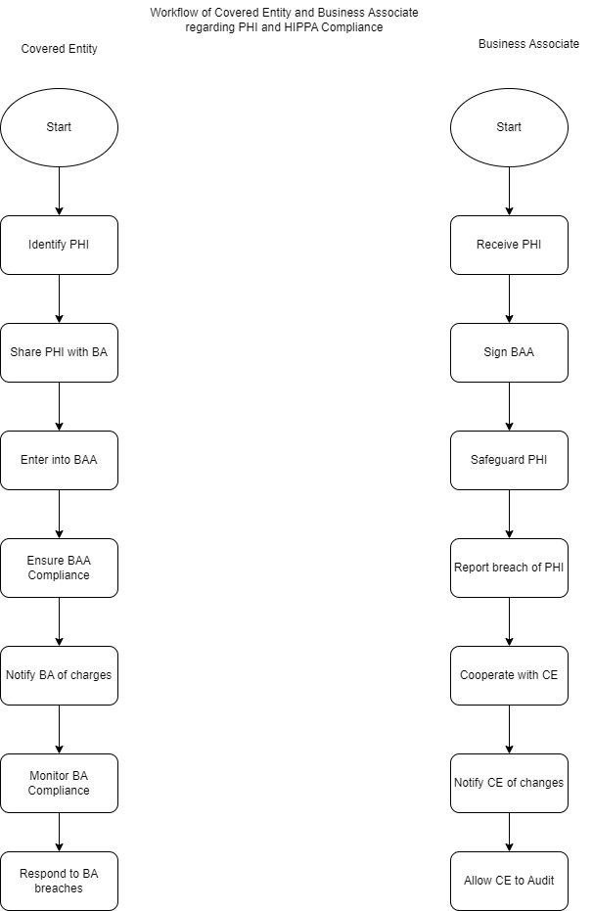

In Revenue Billing System Business associates can related to covered entities in this way

* **Patient Registration:** The patient’s demographic and insurance information is collected and entered into the system. The Business Associate may be involved in the electronic eligibility verification (EDI code 270) to check the patient’s coverage and benefits.
* **Pre-authorization:** The provider may require an authorization from the patient’s insurance plan before providing certain services. The Business Associate can assist the provider in requesting authorization electronically (EDI code 278).
* **Charge Capture:** The services provided to the patient are captured and entered into the system with appropriate codes such as Current Procedural Terminology (CPT) codes, Healthcare Common Procedure Coding System (HCPCS) codes, and Diagnosis codes (ICD-10-CM). The Business Associate may be involved in the electronic charge capture (EDI code 837P).
* **Claim Submission:** The claim containing the patient’s demographic and insurance information, services provided, and charges is submitted to the insurance plan for payment. The Business Associate may be involved in the electronic claim submission (EDI code 837P).
* **Claim Adjudication:** The insurance plan reviews the claim for accuracy and completeness, and then determines the amount of payment. The Business Associate may be involved in the electronic claim adjudication (EDI code 277CA).
* **Payment Posting:** The provider receives the payment and posts it to the patient’s account. The Business Associate may be involved in the electronic remittance advice (ERA) that explains the payment decision and includes the payment amount, adjustment reason codes, and other relevant information (EDI code 835).
* **Denial Management:** If the claim is denied, the provider may investigate and appeal the denial. The Business Associate may be involved in the electronic request for additional information (EDI code 277) to support the appeal.
* **Patient Billing:** The provider bills the patient for any remaining balance after insurance payment is applied. The Business Associate may be involved in the electronic patient statement (EDI code 811).

**Remaining Topics from the list**

**UB-04**

The UB-04 form, also known as the CMS-1450 form, is a standardized billing form used in medical billing to submit insurance claims for inpatient and outpatient medical services. It is used by hospitals, skilled nursing facilities, and other institutional providers to bill Medicare, Medicaid, and private insurance companies.

The UB-04 form contains fields that identify the provider, the patient, and the services provided. The form is divided into multiple sections, with each section representing different information about the claim. The form has 81 fields, but not all fields are required to be completed for every claim. The format of the UB-04 form includes alphanumeric and numeric fields, which allows for the entry of various types of data.

Here are some examples of when the UB-04 form is used in medical billing:

* Hospital inpatient stays
* Outpatient services provided in a hospital or clinic setting
* Skilled nursing facility services
* Home health agency services
* Hospice services
* Ambulance transportation services

The components of the UB-04 form include the following:

* **Provider Information:** This includes the name, address, and National Provider Identifier (NPI) of the provider.
* **Patient Information:** This includes the name, address, date of birth, and insurance information of the patient.
* **Admission and Discharge Dates:** This indicates the dates the patient was admitted and discharged from the facility.
* **Diagnosis and Procedure Codes:** This includes codes used to identify the patient’s diagnosis and the services provided.
* **Revenue Codes:** This identifies the services provided and the charges associated with them.
* **Total Charges:** This indicates the total charges for the services provided.
* **Payer Information:** This includes the name and address of the insurance company responsible for paying the claim.
* **Patient Responsibility:** This indicates the amount the patient is responsible for paying.

In summary, the UB-04 form is a standardized billing form used in medical billing to submit insurance claims for inpatient and outpatient medical services. It is used by institutional providers to bill Medicare, Medicaid, and private insurance companies. The form includes fields for identifying the provider, patient, and services provided, and it is divided into multiple sections.

**Q. What’s the difference between UB-04 form and HCFA in Medical Billing?**

The UB-04 and HCFA are both medical billing forms used to submit healthcare claims to insurance companies, but they are different in several ways.

The UB-04 form, also known as the CMS-1450 form, is used by institutional providers, such as hospitals, nursing homes, and other facilities, to bill for services provided to patients. The form contains specific fields for reporting information such as the patient’s medical record number, diagnosis codes, procedure codes, dates of service, and other billing information. The UB-04 form is used for submitting claims to Medicare, Medicaid, and private insurance companies.

On the other hand, the HCFA-1500 form, also known as the CMS-1500 form, is used by non-institutional providers, such as physicians, therapists, and other healthcare professionals, to bill for services provided to patients. The form also contains specific fields for reporting information such as the patient’s name, address, date of birth, diagnosis codes, procedure codes, dates of service, and other billing information. The HCFA-1500 form is used for submitting claims to Medicare, Medicaid, and private insurance companies.

Even though the CMS-1500 form is based on the CMS-1450 from but there is a huge difference when it comes to their usage. It is because the hospitals or institutions may not charge for procedures but the physicians do charge their procedures to get compensation. Therefore, CMS-1500 form is used by physicians only. However, the institutions where insured patients visit to get treatment are also required to get reimbursement to maintain a healthy revenue cycle.

**Structure of UB-04 and CMS-1500 Forms**

The CMS-1450 consists of 81 fields or form locators called FL that are used to fill specific information. Some of the examples of FL along with the details are as follows:

* FL 1—Billing provider name, street address, city, state, zip, telephone, fax, and country code
* FL 2—Billing provider’s designated Pay—name, address, city, ID
* FL 3—Patient control number and the medical record number for your facility
* Fl 4—Type of bill
* FL 6—Statement from and through dates for the service covered on the claim, in MMDDYY (month, date, and year) format
* FL 81—Taxonomy code and qualifier (the last locator on the form)

The CMS-1500 form consists of 33 items to fill the necessary details for claim purposes. Some of the examples of the items on the CMS-1500 are as following:

* Item 1—Medicare/Medicaid/Tricare/CHAMPVA/Group Health Plan/FECA BLK LUNG/Other
* Item 2—Patient’s name
* Item 3—Patient’s date of birth and Sex
* Item 4—Insured’s name
* Item 5—Patient’s address
* Item 33—Billing provider information and phone number

It is important to note that the CMS-1500 is divided into three parts—carrier block, patient and insured information, and physician or supplier information.

**Partial Payment**

In US healthcare, partial payment refers to a situation where a patient or their insurance company pays only a portion of the total amount billed for a service or procedure, while the remaining balance is left to be paid by the patient.

There are several scenarios where partial payments may occur in the US healthcare system:

* **Deductibles:** Many insurance plans have an annual deductible, which is the amount that the patient must pay out of pocket before the insurance company begins to cover the cost of services. For example, if a patient has a $1,000 deductible and receives a $5,000 service, the patient would be responsible for paying $1,000 and the insurance company would pay the remaining $4,000.
* **Co-insurance:** Co-insurance is a type of cost-sharing where the patient and the insurance company each pay a percentage of the total cost of a service. For example, if a patient has a 20% co-insurance and receives a $1,000 service, the patient would be responsible for paying $200 and the insurance company would pay $800.
* **Out-of-network services:** If a patient receives services from a provider that is not in their insurance company's network, the insurance company may only pay a portion of the total cost of the service. In this case, the patient would be responsible for paying the difference between the amount billed by the provider and the amount paid by the insurance company.
* **Maximum allowable amount:** Some insurance plans have a maximum allowable amount for certain services or procedures. If the provider bills more than the maximum allowable amount, the patient may be responsible for paying the difference.
* **Non-covered services:** Some services or procedures may not be covered by the patient's insurance plan. In this case, the patient would be responsible for paying the entire amount billed by the provider.

In all of these scenarios, the patient would be responsible for paying the partial payment to the provider. The provider may offer payment plans or other options to help the patient pay the balance over time. It's important for patients to understand their insurance coverage and any out-of-pocket costs that they may be responsible for before receiving services to avoid unexpected partial payments.

**Reversal Payment**

In US healthcare, a reversal payment is a type of refund that is issued by a healthcare provider or insurance company to reverse a previously processed payment for a service or procedure. There are several scenarios where a reversal payment may be applied:

* **Duplicate payments**: If a provider or insurance company accidentally processes a payment twice for the same service or procedure, a reversal payment may be issued to refund the duplicate payment.
* **Overpayments:** If a provider or insurance company overpays for a service or procedure, a reversal payment may be issued to refund the excess amount.
* **Canceled services:** If a service or procedure is canceled before it is provided, a reversal payment may be issued to refund any payment that was made for the service or procedure.
* **Incorrect payments:** If a provider or insurance company processes a payment for the wrong service or procedure or for the wrong amount, a reversal payment may be issued to correct the error and refund the incorrect payment.

For example, if a patient receives a service that costs $1,000 and the insurance company processes a payment of $1,500 by mistake, the insurance company may issue a reversal payment of $500 to correct the error and refund the excess amount.

It's important to note that reversal payments may also result in adjustments to the patient's billing statement. For example, if a patient paid a $500 deductible for a service that was later canceled, the provider may issue a reversal payment of $500 to refund the patient's payment, and also adjust the billing statement to remove the charge for the canceled service.

Reversal payments are an important part of the healthcare billing process, as they help to correct errors and ensure that patients are not overcharged for services or procedures. Providers and insurance companies have procedures in place to handle reversal payments and ensure that they are processed accurately and in a timely manner.

**Write OFF Amount**

In US healthcare, a write-off refers to the amount that a healthcare provider agrees to waive or not collect from a patient or an insurance company for medical services provided. Write-offs occur for a variety of reasons, including contractual agreements between providers and insurance companies, discounts negotiated by providers, or financial hardship experienced by patients.

Write-offs are an important aspect of the US healthcare system because they help providers and patients navigate the complex landscape of insurance coverage and medical billing. By writing off a portion of the cost of medical services, providers can help ensure that patients have access to necessary medical treatments, regardless of their ability to pay.

There are several scenarios where write-offs are applied in US healthcare, including:

* **Uninsured patients:** When patients do not have insurance, healthcare providers may write off a portion of the cost of medical services to help make care more affordable. In some cases, providers may offer discounts or payment plans to uninsured patients to help manage the cost of care.
* **Out-of-network care:** When patients receive care from a provider that is not in their insurance company's network, the provider may agree to write off a portion of the cost of care. In these cases, the provider may negotiate a discount with the insurance company or waive the cost of care altogether.
* **Financial hardship:** When patients experience financial hardship and are unable to pay for medical services, providers may agree to write off a portion of the cost of care. In these cases, providers may work with patients to set up payment plans or offer discounts to help manage the cost of care.
* **Contractual agreements:** Healthcare providers and insurance companies may negotiate contracts that include write-offs for certain medical services. In these cases, providers agree to accept a reduced payment from the insurance company in exchange for writing off the remaining cost of care.

Examples of write-off scenarios include:

* A patient receives medical services that cost $1,000. The patient's insurance company agrees to pay $700 of the cost of care, and the healthcare provider writes off the remaining $300 as part of a contractual agreement with the insurance company.
* An uninsured patient receives medical services that cost $500. The healthcare provider writes off $200 of the cost of care to help make the services more affordable for the patient.
* A patient receives medical services from an out-of-network provider that cost $2,000. The provider negotiates a discount with the insurance company, and agrees to write off $500 of the cost of care.

Overall, write-offs are an important aspect of the US healthcare system that help ensure patients have access to necessary medical treatments, regardless of their ability to pay. Understanding the different scenarios where write-offs are applied can help patients and providers navigate the complex landscape of healthcare costs and insurance coverage.

**Patient Advance/ Over Payment**

In US healthcare, a patient advance/overpayment refers to a situation where a patient pays more than the actual cost of medical services received. This can occur for several reasons, including errors in billing, overpayment by insurance companies, or prepayment for services that are ultimately not needed.

Patient advance/overpayment can have significant implications for patients, healthcare providers, and insurance companies. If a patient is overcharged for medical services, they may experience financial hardship and difficulty obtaining necessary care. Healthcare providers may be required to issue refunds or face legal action if overpayments are not resolved. Insurance companies may also need to reimburse patients for overpayments and may face financial penalties for overcharging patients.

Examples of scenarios where patient advance/overpayment can occur in US healthcare include:

* **Billing errors:** If a healthcare provider makes an error in billing for medical services, a patient may be overcharged for the cost of care. For example, if a provider bills for a procedure that was not performed or bills for a higher level of care than was provided, the patient may be overcharged.
* **Overpayment by insurance companies:** Insurance companies may make errors in processing claims or overpay for medical services. If a patient receives a payment from their insurance company that is more than the actual cost of care, they may be required to return the excess funds to the insurance company.
* **Prepayment for services not provided:** In some cases, patients may prepay for medical services that are ultimately not needed. If a patient pays in advance for a medical procedure that is later cancelled or not performed, they may be entitled to a refund of the overpayment.
* **Changes in insurance coverage:** If a patient changes insurance coverage during the course of medical treatment, they may be overcharged for medical services. For example, if a patient receives medical services under one insurance plan and then switches to a different plan, the provider may bill the new insurance company for services that were already paid for by the previous insurance company.

In order to resolve patient advance/overpayment scenarios, healthcare providers may need to issue refunds to patients or insurance companies. Patients can work with their providers and insurance companies to resolve billing errors and other issues related to overpayment.

Overall, patient advance/overpayment is a common issue in US healthcare that can have significant implications for patients, providers, and insurance companies. By understanding the different scenarios where overpayment can occur, patients and providers can work together to resolve billing errors and ensure that patients receive affordable and appropriate medical care.

**Q. What’s the difference between Reversal Payment and Payment Advance/Over Payment in US Medical Billing?**

Reversal payment is a process in which a payment that has been previously made is reversed or cancelled. It usually occurs when an overpayment or an error is detected in a previous payment. In medical billing, a reversal payment is typically initiated by the healthcare provider or the insurance company to correct an erroneous payment or refund an overpayment.

On the other hand, payment advance/overpayment refers to a situation in which a payment is made in advance or in excess of the actual amount owed. This could occur if the patient overpays a bill or if the insurance company pays more than the amount of the claim. In such cases, the provider is responsible for refunding the excess payment to the patient or the insurance company.

In summary, reversal payment involves cancelling or correcting a previous payment, while payment advance/overpayment refers to paying more than the actual amount owed.

**Difference between Provider and Resource**

In US healthcare, the terms "provider" and "resource" have different meanings and are used in different contexts.

A provider is a licensed healthcare professional or organization that delivers medical care or services to patients. Examples of healthcare providers include doctors, nurses, nurse practitioners, physician assistants, hospitals, clinics, and home health agencies.

On the other hand, a resource refers to anything that can be used to support the provision of healthcare services. Resources can include medical equipment, facilities, financial resources, technology, and human resources. For example, hospitals and clinics can be considered resources in the healthcare system because they provide a physical location and infrastructure for delivering care. Other examples of resources include medical devices and equipment, laboratory services, and medical research institutions.

In summary, providers are the individuals or organizations who directly deliver healthcare services to patients, while resources are the tools and infrastructure that support the delivery of healthcare services.

**CLIA**

CLIA stands for Clinical Laboratory Improvement Amendments, which are federal regulations in the United States that govern laboratory testing and require all clinical laboratories to meet certain quality standards. The CLIA regulations are administered by the Centers for Medicare and Medicaid Services (CMS) and apply to any laboratory that performs testing on human specimens for the purpose of providing information for diagnosis, prevention, or treatment of disease.

The purpose of CLIA is to ensure that laboratory testing is accurate, reliable, and timely, and that laboratories provide high-quality services to patients. The CLIA program sets standards for laboratory operations, including personnel qualifications, quality control and quality assurance measures, proficiency testing, and recordkeeping requirements.

There are three levels of CLIA certification based on the complexity of laboratory testing performed:

* **CLIA waived tests** - These are the simplest tests that are easy to perform and have a low risk of error. Examples of CLIA waived tests include home pregnancy tests, urine dipsticks, and some rapid strep tests.
* **Moderate complexity tests** - These are more complex tests that require some training and skill to perform. Examples of moderate complexity tests include most blood tests, urine culture tests, and certain infectious disease tests.
* **High complexity tests** - These are the most complex tests that require highly trained personnel and specialized equipment to perform. Examples of high complexity tests include genetic testing, microbiology tests, and histopathology tests.

In order to be certified under CLIA, laboratories must meet certain requirements, including having appropriately trained personnel, using standardized procedures and equipment, performing regular quality control testing, and participating in proficiency testing programs to ensure accuracy and reliability of test results. The CLIA program also includes inspections of laboratories to ensure compliance with the regulations.

Overall, the CLIA program plays a critical role in ensuring the quality and accuracy of laboratory testing in the United States, and helps to protect the health and well-being of patients by ensuring that laboratory tests are reliable and accurate.

**Claim Statuses**

In the US healthcare system, there are several claim statuses that may be used to indicate the current state of a claim. These statuses can help healthcare providers, insurers, and patients track the progress of a claim and ensure that it is being processed correctly. Some common claim statuses and their codes include:

* **Pending:** This status means that the claim has been received and is being reviewed. It may also indicate that additional information or documentation is needed before the claim can be processed. Code: 001.
* **Denied:** This status means that the claim has been reviewed and has been determined to be ineligible for reimbursement. This may be due to a number of reasons, such as incorrect information, lack of coverage, or incorrect coding. Code: 002.
* **Approved:** This status means that the claim has been reviewed and approved for reimbursement. The payment amount and any deductible or copayment amounts will be calculated and the claim will be processed for payment. Code: 003.
* **Paid:** This status means that the approved claim has been paid and the payment has been issued to the healthcare provider. Code: 004.
* **Pending payment:** This status means that the claim has been approved and is waiting for payment to be issued. Code: 005.
* **Processing:** This status means that the claim is currently being reviewed and processed. Code: 006.
* **Rejected:** This status means that the claim has been rejected and cannot be resubmitted. This may be due to errors in coding, incorrect information, or lack of coverage. Code: 007.

The specific claim statuses and codes may vary depending on the healthcare provider or insurer. The scenarios in which each status is given can also vary, but typically they are used to track the progress of a claim from submission to payment or denial.

**NF 3 Forms**

The NF3 form is a document used in the US healthcare system that explains a patient's rights and responsibilities when it comes to healthcare services that are not covered by their insurance. It is used in situations where a patient wants a service or treatment that is not covered by their insurance, or when they do not want to receive a covered service.

Here are some examples of when the NF3 form might be used:

* If a patient wants to undergo a cosmetic procedure that is not medically necessary, such as a nose job or breast augmentation, the healthcare provider may have the patient sign an NF3 form to acknowledge that the service is not covered by insurance and that they will be responsible for the cost.
* If a patient has a medical condition that requires treatment, but they do not want to receive the recommended treatment because of personal or religious beliefs, the healthcare provider may have the patient sign an NF3 form to acknowledge that they are declining the recommended treatment.
* If a patient wants to participate in a clinical trial for an experimental treatment that is not yet approved by the FDA, the healthcare provider may have the patient sign an NF3 form to acknowledge that the treatment is not covered by insurance and that they may be responsible for any costs associated with the trial.

In each of these scenarios, the NF3 form helps to ensure that the patient understands the financial implications of their decision and that they are making an informed choice about their healthcare. The form also protects the healthcare provider from potential legal issues by documenting that the patient has been informed about the risks and costs associated with the service or treatment.

**C4 Forms**

The C4 form in worker compensation is a document used in the United States healthcare system to report and document work-related injuries or illnesses. It is used by healthcare providers to communicate important information about a patient's work-related injury or illness to their employer and their insurance company.

When a worker gets injured or becomes ill as a result of their job, they may need to file a worker compensation claim to receive benefits, such as medical treatment, lost wages, and disability benefits. To initiate this process, the worker needs to report their injury or illness to their employer and seek medical attention. The healthcare provider who treats the worker then completes a C4 form to document the injury or illness and its related medical treatment.

For example, if a construction worker falls off a ladder and breaks their arm, they would seek medical attention from a healthcare provider. The healthcare provider would then fill out a C4 form, documenting the worker's injury, the medical treatment provided, and any restrictions or limitations the worker may have as a result of their injury. This information would then be submitted to the worker's employer and their insurance company to determine the appropriate compensation and benefits.

The employee has 90 days from the date of injury to seek medical treatment. The medical provider will give you a copy of this form and will forward a copy to the worker’s compensation office and/or the third-party administrator. If you are treated at a medical facility that is not on the approved workers compensation provider list, be sure to check with the worker’s compensation office to ensure that the C-4 form has been received from the out of network facility. Your claim cannot be processed for a worker’s compensation claim without the completed C-4 form.

Overall, the C4 form plays an important role in the worker compensation process, as it helps to ensure that injured or ill workers receive the necessary medical treatment and compensation they need to recover and return to work.

**Provider Types**

There are many provider types other than Billing and Rendering Provider, some of them are explained below:

**Supervisory Provider**

A Supervisory provider is a healthcare provider who supervises or oversees the care provided by another healthcare provider, such as a physician assistant. Who are less experienced or have a lower level of training.

The supervisory provider is responsible for ensuring that the care provided to patients is of high quality and meets professional standards. The type of supervisory provider varies depending on the setting, but may include physicians, nurse practitioners, physician assistants, or other healthcare professionals.

In some cases, the supervisory provider may be responsible for directly supervising the work of other healthcare providers, such as nurses or medical assistants. This may involve providing guidance and direction on patient care, monitoring the quality of care being provided, and ensuring that all protocols and procedures are being followed.

For example, in a hospital setting, a physician may be the supervisory provider for a team of nurses who are caring for a patient. The physician would be responsible for reviewing the patient's care plan, monitoring the patient's progress, and providing guidance and direction to the nurses as needed.

In other cases, the supervisory provider may have a more indirect role, such as overseeing the work of healthcare providers who are working in different locations or providing care remotely. In these cases, the supervisory provider may review patient charts and communicate with other healthcare providers to ensure that patients are receiving the appropriate care.

Overall, the role of the supervisory provider is critical in ensuring that patients receive high-quality, safe, and effective care in US healthcare settings.

**Referring Provider**

In US healthcare, a referring provider is a licensed healthcare professional who recommends or refers a patient to another provider or facility for additional care or services. The referring provider may be a physician, nurse practitioner, physician assistant, or other healthcare professional.

The referring provider is responsible for identifying the need for additional care or services beyond what they can provide themselves and finding a qualified provider or facility to meet those needs. The referring provider may also coordinate with the other provider or facility to ensure that the patient receives appropriate care and that the treatment plan is consistent with the referring provider's goals for the patient's care.

For example, if a patient presents to their primary care physician with symptoms that suggest they may have a heart condition, the primary care physician may refer the patient to a cardiologist for further evaluation and treatment. The primary care physician would provide the cardiologist with information about the patient's medical history and any previous tests or treatments, and would work with the cardiologist to develop a treatment plan for the patient.

In another example, a patient may see an orthopedic surgeon for a knee injury, and the orthopedic surgeon may refer the patient to a physical therapist for rehabilitation. The orthopedic surgeon would work with the physical therapist to develop a rehabilitation plan for the patient and may continue to monitor the patient's progress as they recover.

In some cases, insurance plans require a referral from a primary care provider before a patient can see a specialist. This helps to ensure that patients are receiving appropriate care and that unnecessary tests or treatments are avoided.

Overall, the role of the referring provider is critical in ensuring that patients receive appropriate and timely care and that their treatment is coordinated between different healthcare providers and facilities.

**Ordering Provider**

In US healthcare, an ordering provider is a licensed healthcare professional who is responsible for ordering diagnostic tests or procedures for a patient. The ordering provider may be a physician, nurse practitioner, physician assistant, or other healthcare professional.

The ordering provider is responsible for identifying the need for a test or procedure and determining the appropriate test or procedure to order based on the patient's symptoms, medical history, and other relevant information. The ordering provider must also ensure that the test or procedure is medically necessary and appropriate for the patient's condition, and that the risks and benefits of the test or procedure are clearly explained to the patient.

For example, if a patient presents to their primary care physician with symptoms that suggest they may have a urinary tract infection, the primary care physician may order a urine culture and sensitivity test to confirm the diagnosis and identify the appropriate antibiotic to treat the infection. The primary care physician would explain the purpose of the test to the patient, as well as any risks or discomfort associated with the test.

In another example, if a patient is scheduled for surgery, the surgeon may order a pre-operative blood test to assess the patient's overall health and identify any potential risk factors that could affect the surgery. The surgeon would explain the purpose of the test to the patient, as well as any risks or discomfort associated with the test.

The ordering provider may also be responsible for reviewing the results of the test or procedure and determining the appropriate course of treatment based on those results. The ordering provider may consult with other healthcare providers, such as a radiologist or pathologist, to interpret the results and develop a treatment plan for the patient.

Overall, the role of the ordering provider is critical in ensuring that patients receive appropriate and effective care based on accurate and timely diagnostic information. The ordering provider must ensure that tests and procedures are ordered and interpreted correctly, and that the patient's treatment plan is tailored to their specific needs and medical history.